**Tutorial 06 Template**

If you have difficulties completing this assignment, please inform the instructor and consider working with DePaul tutors.

**Instructions for completing template:***Replace* **[bracketed red text]** *with the requested information.  
Do not include full screen shot images, or full screen shots that are reduced in size. Use a snippet tool to capture parts of the screen and insert those images into the template.***Please do not alter template numbering.  
Each answer and screen capture are worth equal points.**

**PART A – Getting started Student Contact Information**

**1. Student Name: Abel Marin [A01]**

**2. Student Contact Information:   
marinabe1416@gmail.com [A02]   
(630) 608-8570 [A03]**

**Go back to the tutorial instructions and begin working on part B.**

**Part B1 – Create a WordPress site on a shared web host**

1. Enter the following shared web host WordPress site information **[B1]**
   1. Shared Web Host Company Name: [ SiteGround ]
   2. In Directory Name: [ **tutorial06** ]
   3. Website Admin Username: [ ajmarin ]
   4. Website Admin Password: [ 00VIK4G8m@ ]
   5. Database Name: [ wp829 ]
   6. Table Prefix: [ wpcu_ ]

**OR**

**Part B2 – Create a WordPress site on Pantheon (PaaS)**

1. Enter the following shared web host WordPress site information **[B2]**
   1. PaaS WordPress Front end site URL: [ website URL here ]
   2. PaaS WordPress site Admin Username: [ website admin username here ]
   3. PaaS WordPress site Admin Password: [ website admin password here ]

**Go back to the tutorial instructions and begin working on part C.**

**Part C –** Flesh out the WordPress site with Images, a theme, and a menu, pages, posts, category and tags.  
**Please make sure all Part C screen capture include the web browser address bar. [C]**

1. Take screen captures of the backend administration WordPress site Dashboard   
   **[C.1]  
   [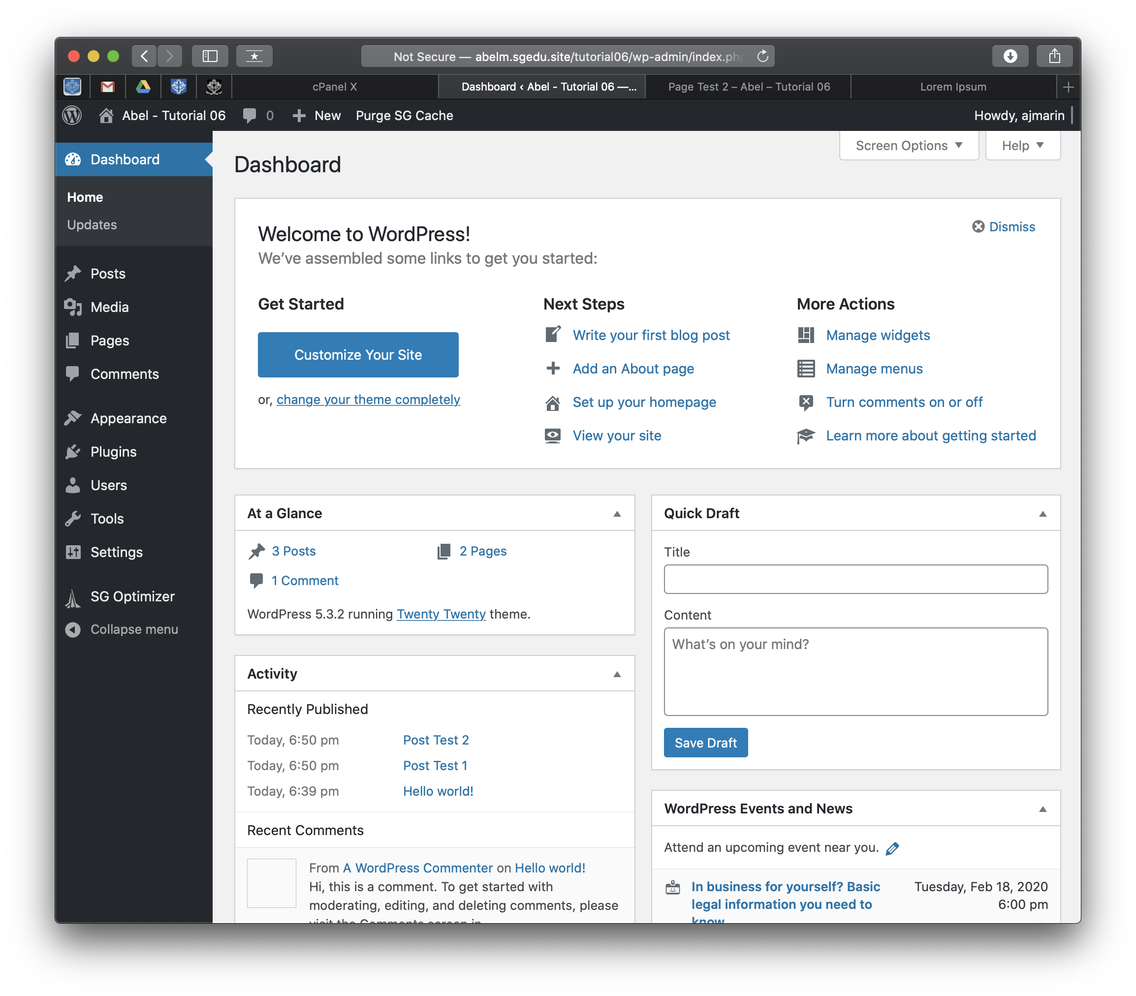]**
2. Take screen captures of the backend administration WordPress site Dashboard > Appearance > Media page – with the media library in GRID mode   
   **[C.2]  
   [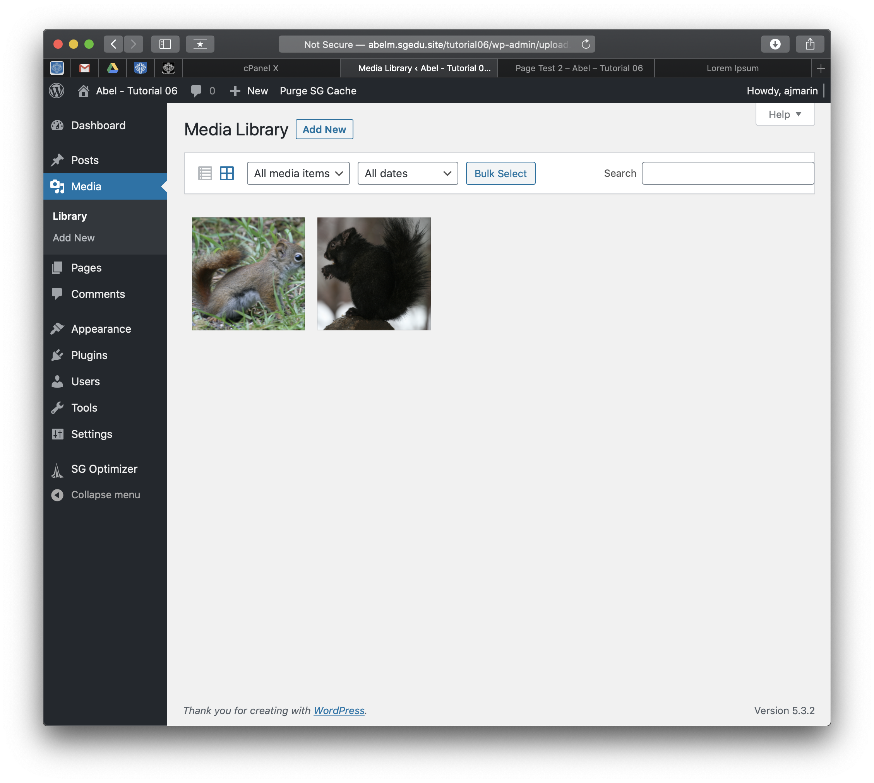]**
3. Take screen captures of the backend administration WordPress site Dashboard > Appearance **[C.3]  
   [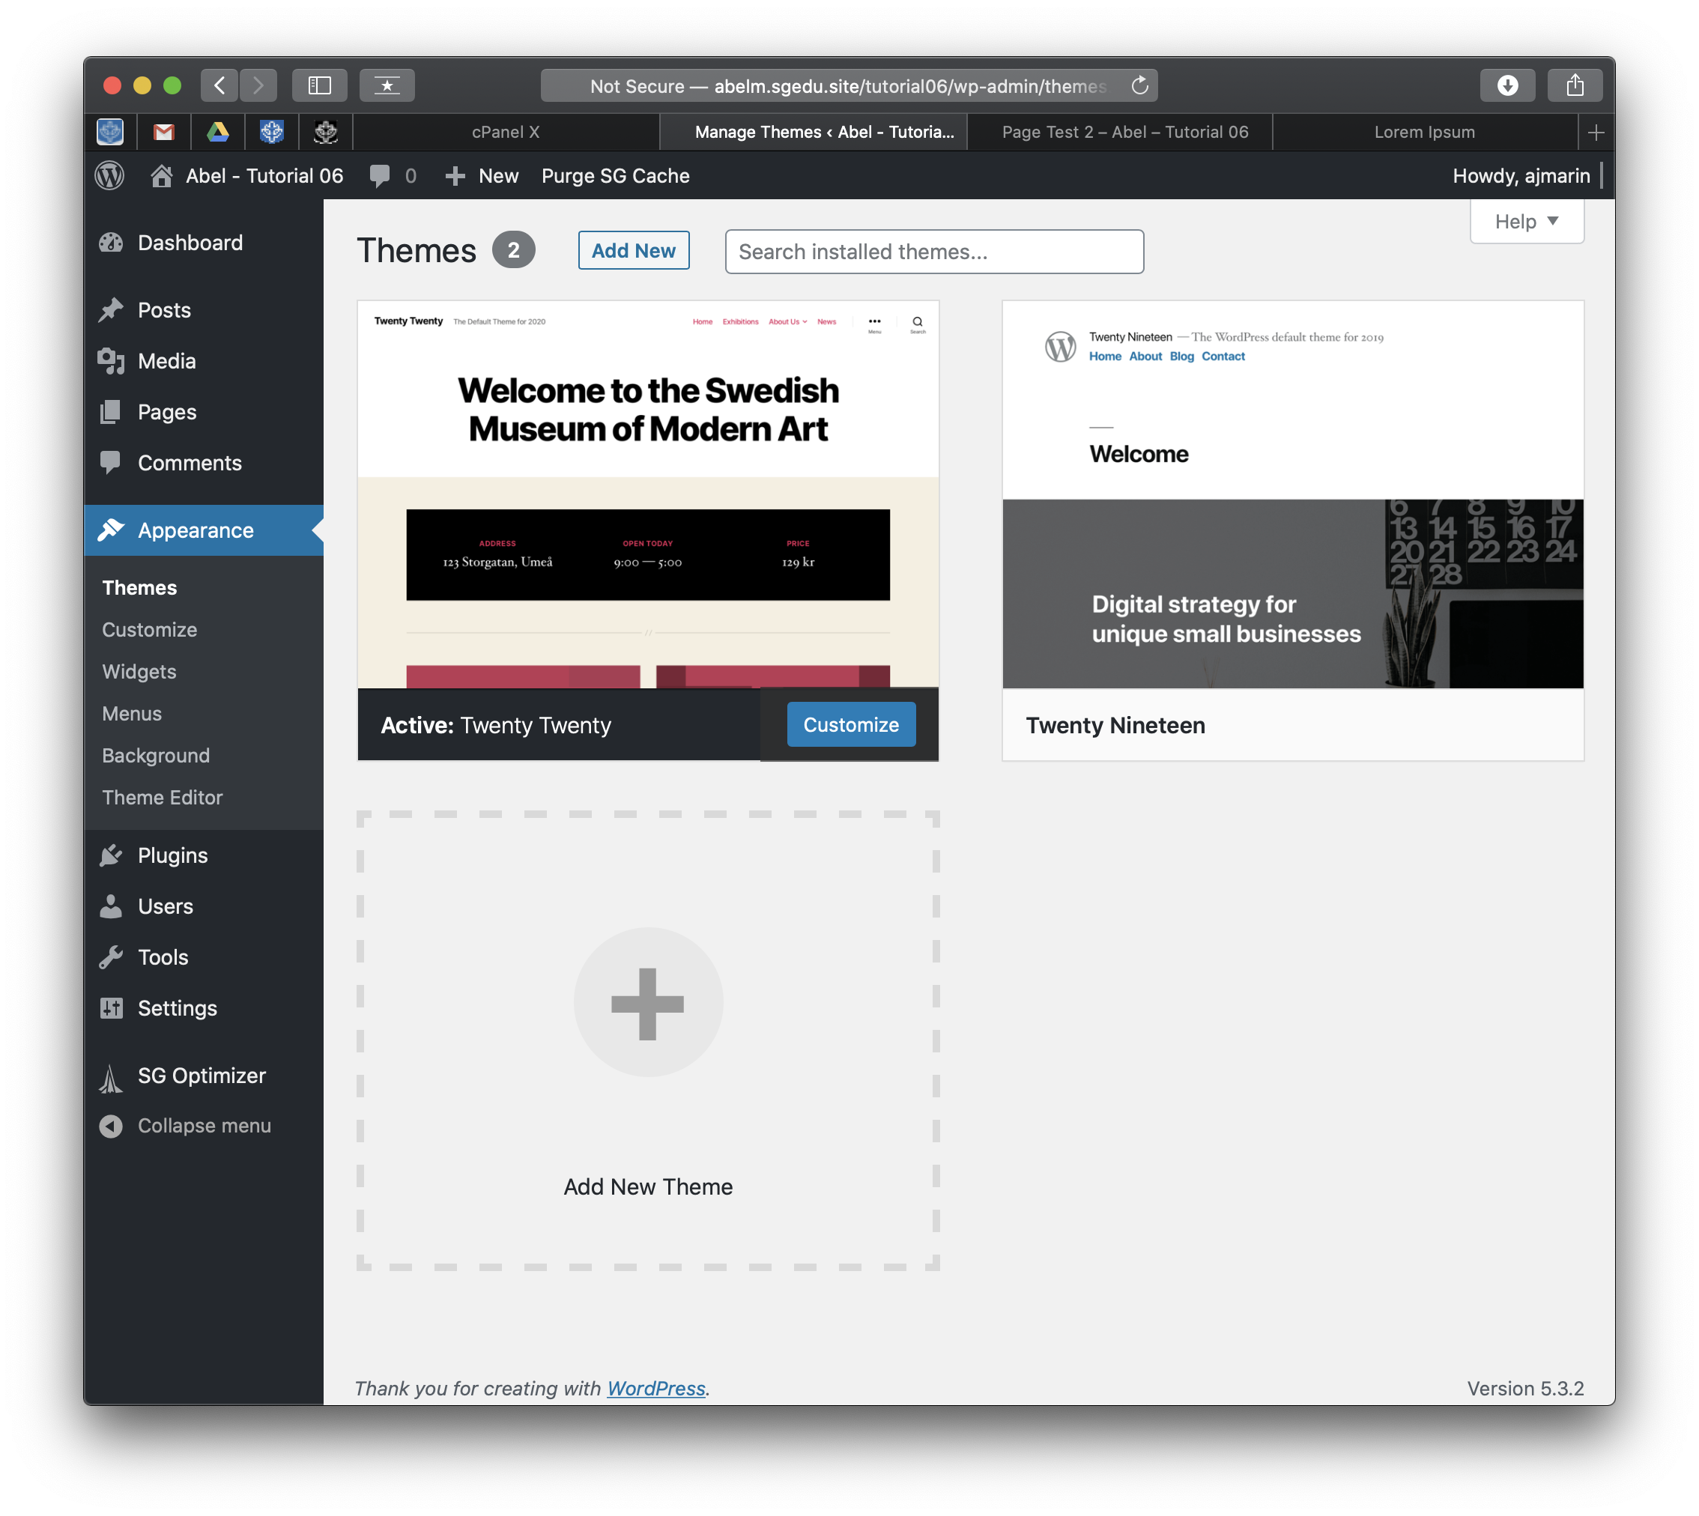]**
4. Take screen captures of the backend administration WordPress site Dashboard >   
   Appearance > Menus   
   **[C.4]  
   [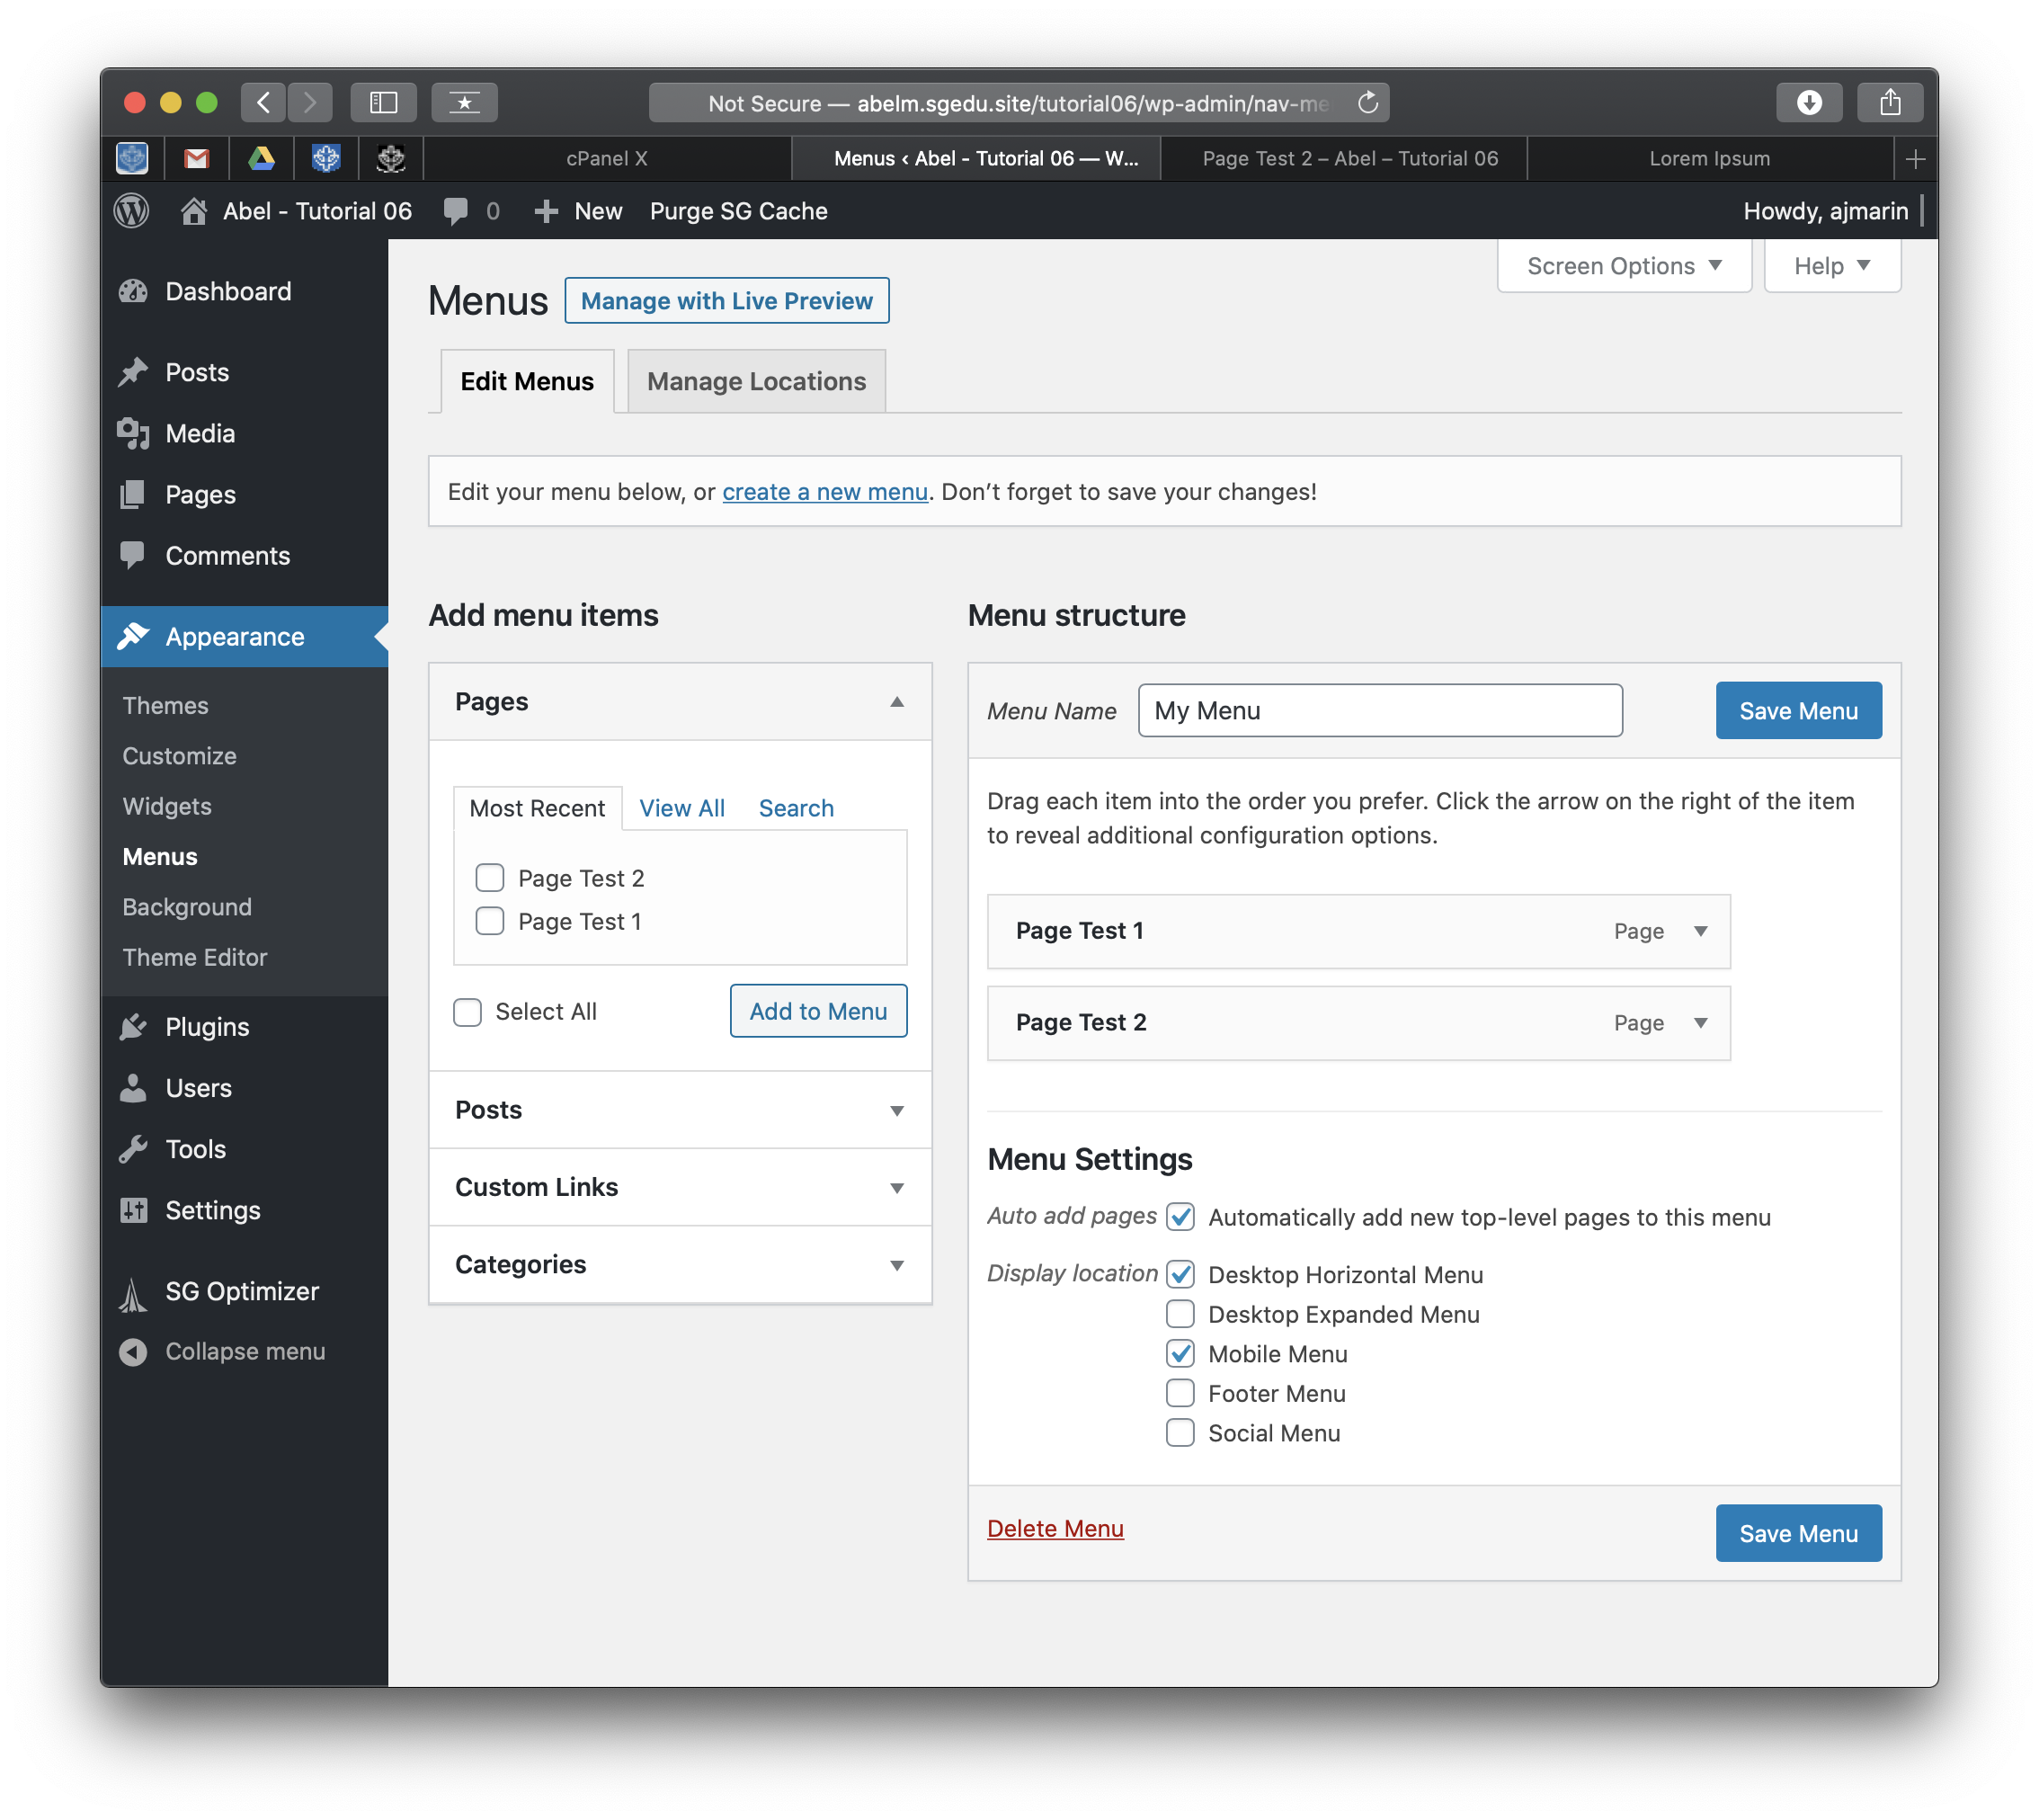]**
5. Take screen captures of the backend administration WordPress site Dashboard > Pages   
   **[C.5]  
   [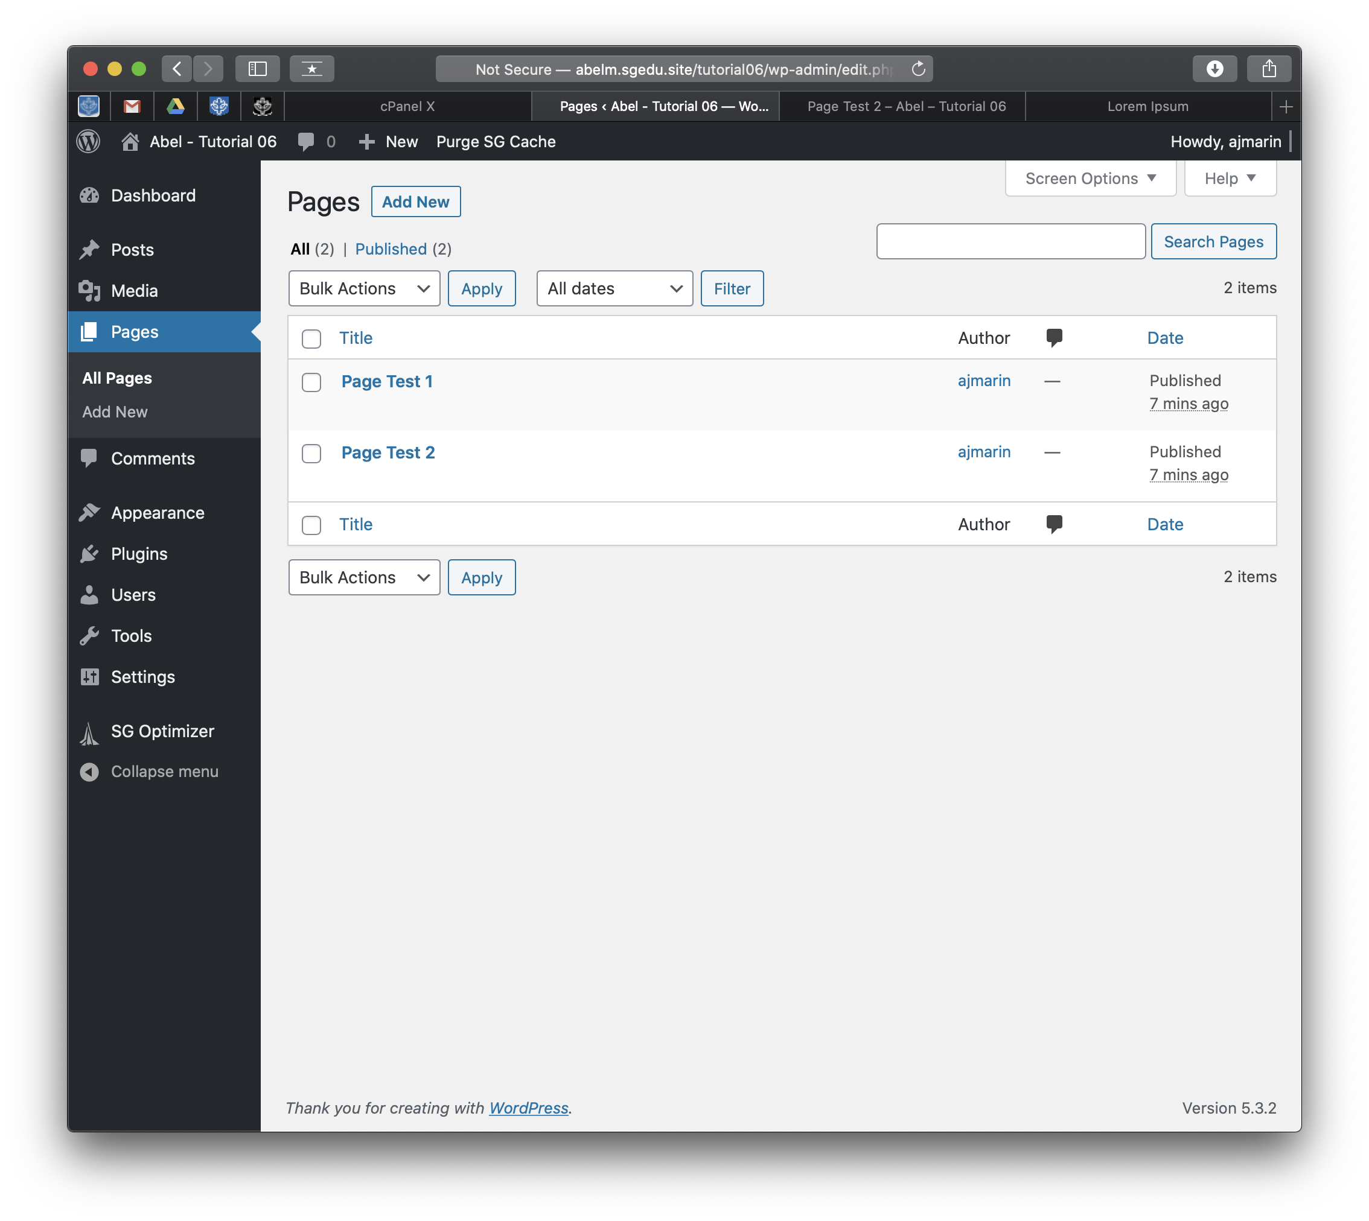]**
6. Take screen captures of the backend administration WordPress site Dashboard >   
   Posts > Categories  
   **[C.6]  
   [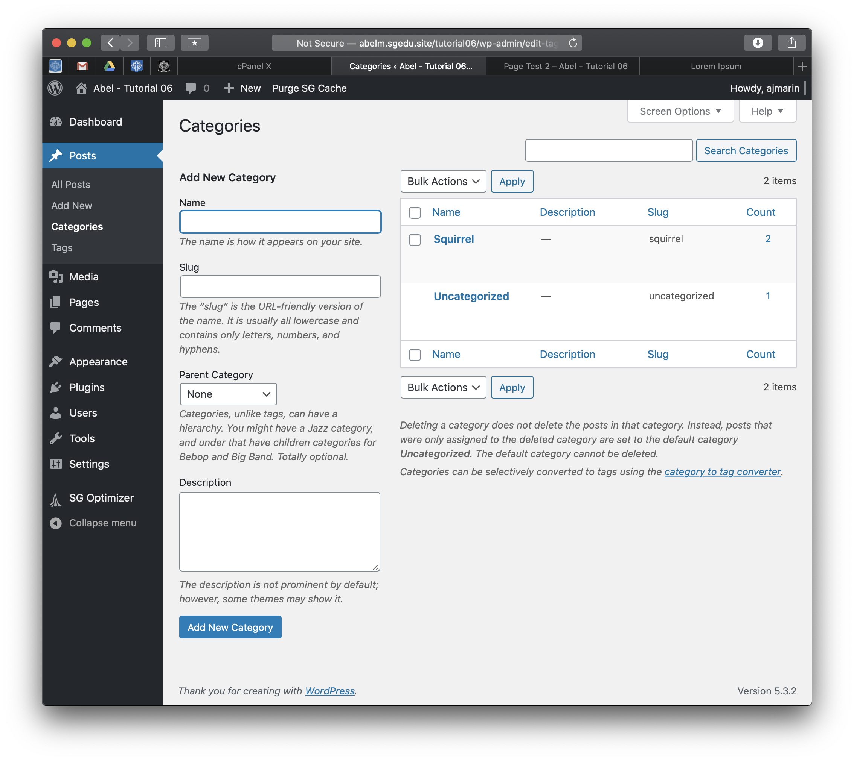]**
7. Take screen captures of the backend administration WordPress site Dashboard > Posts >Tags   
   **[C.7]  
   [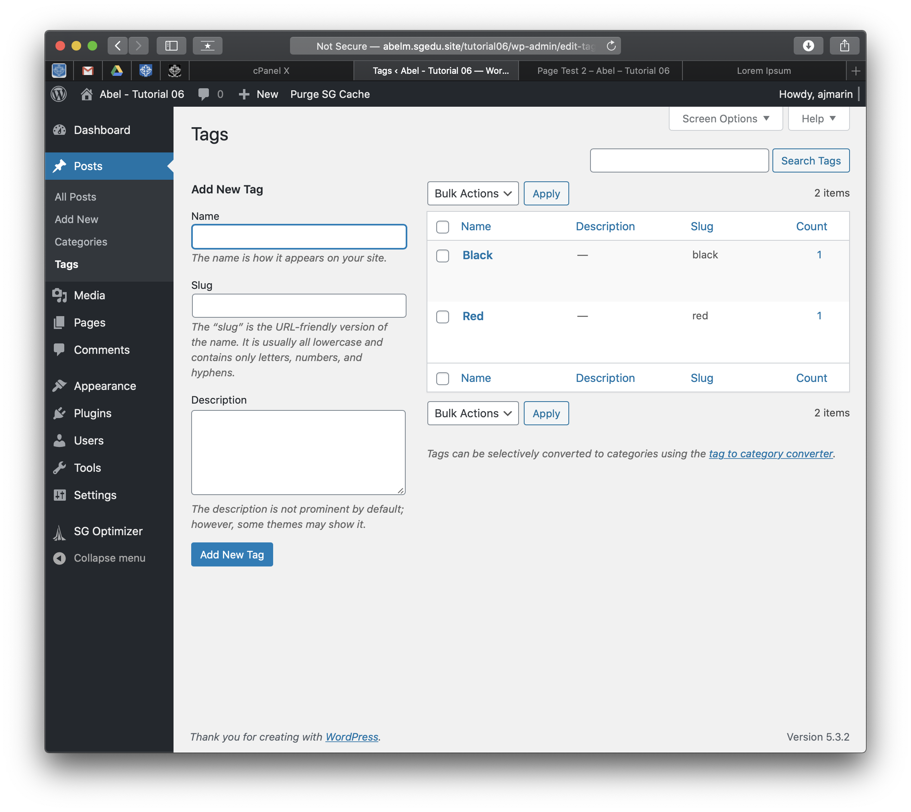]**
8. Take screen captures of the backend administration WordPress site Dashboard > Posts   
   **[C.6]  
   [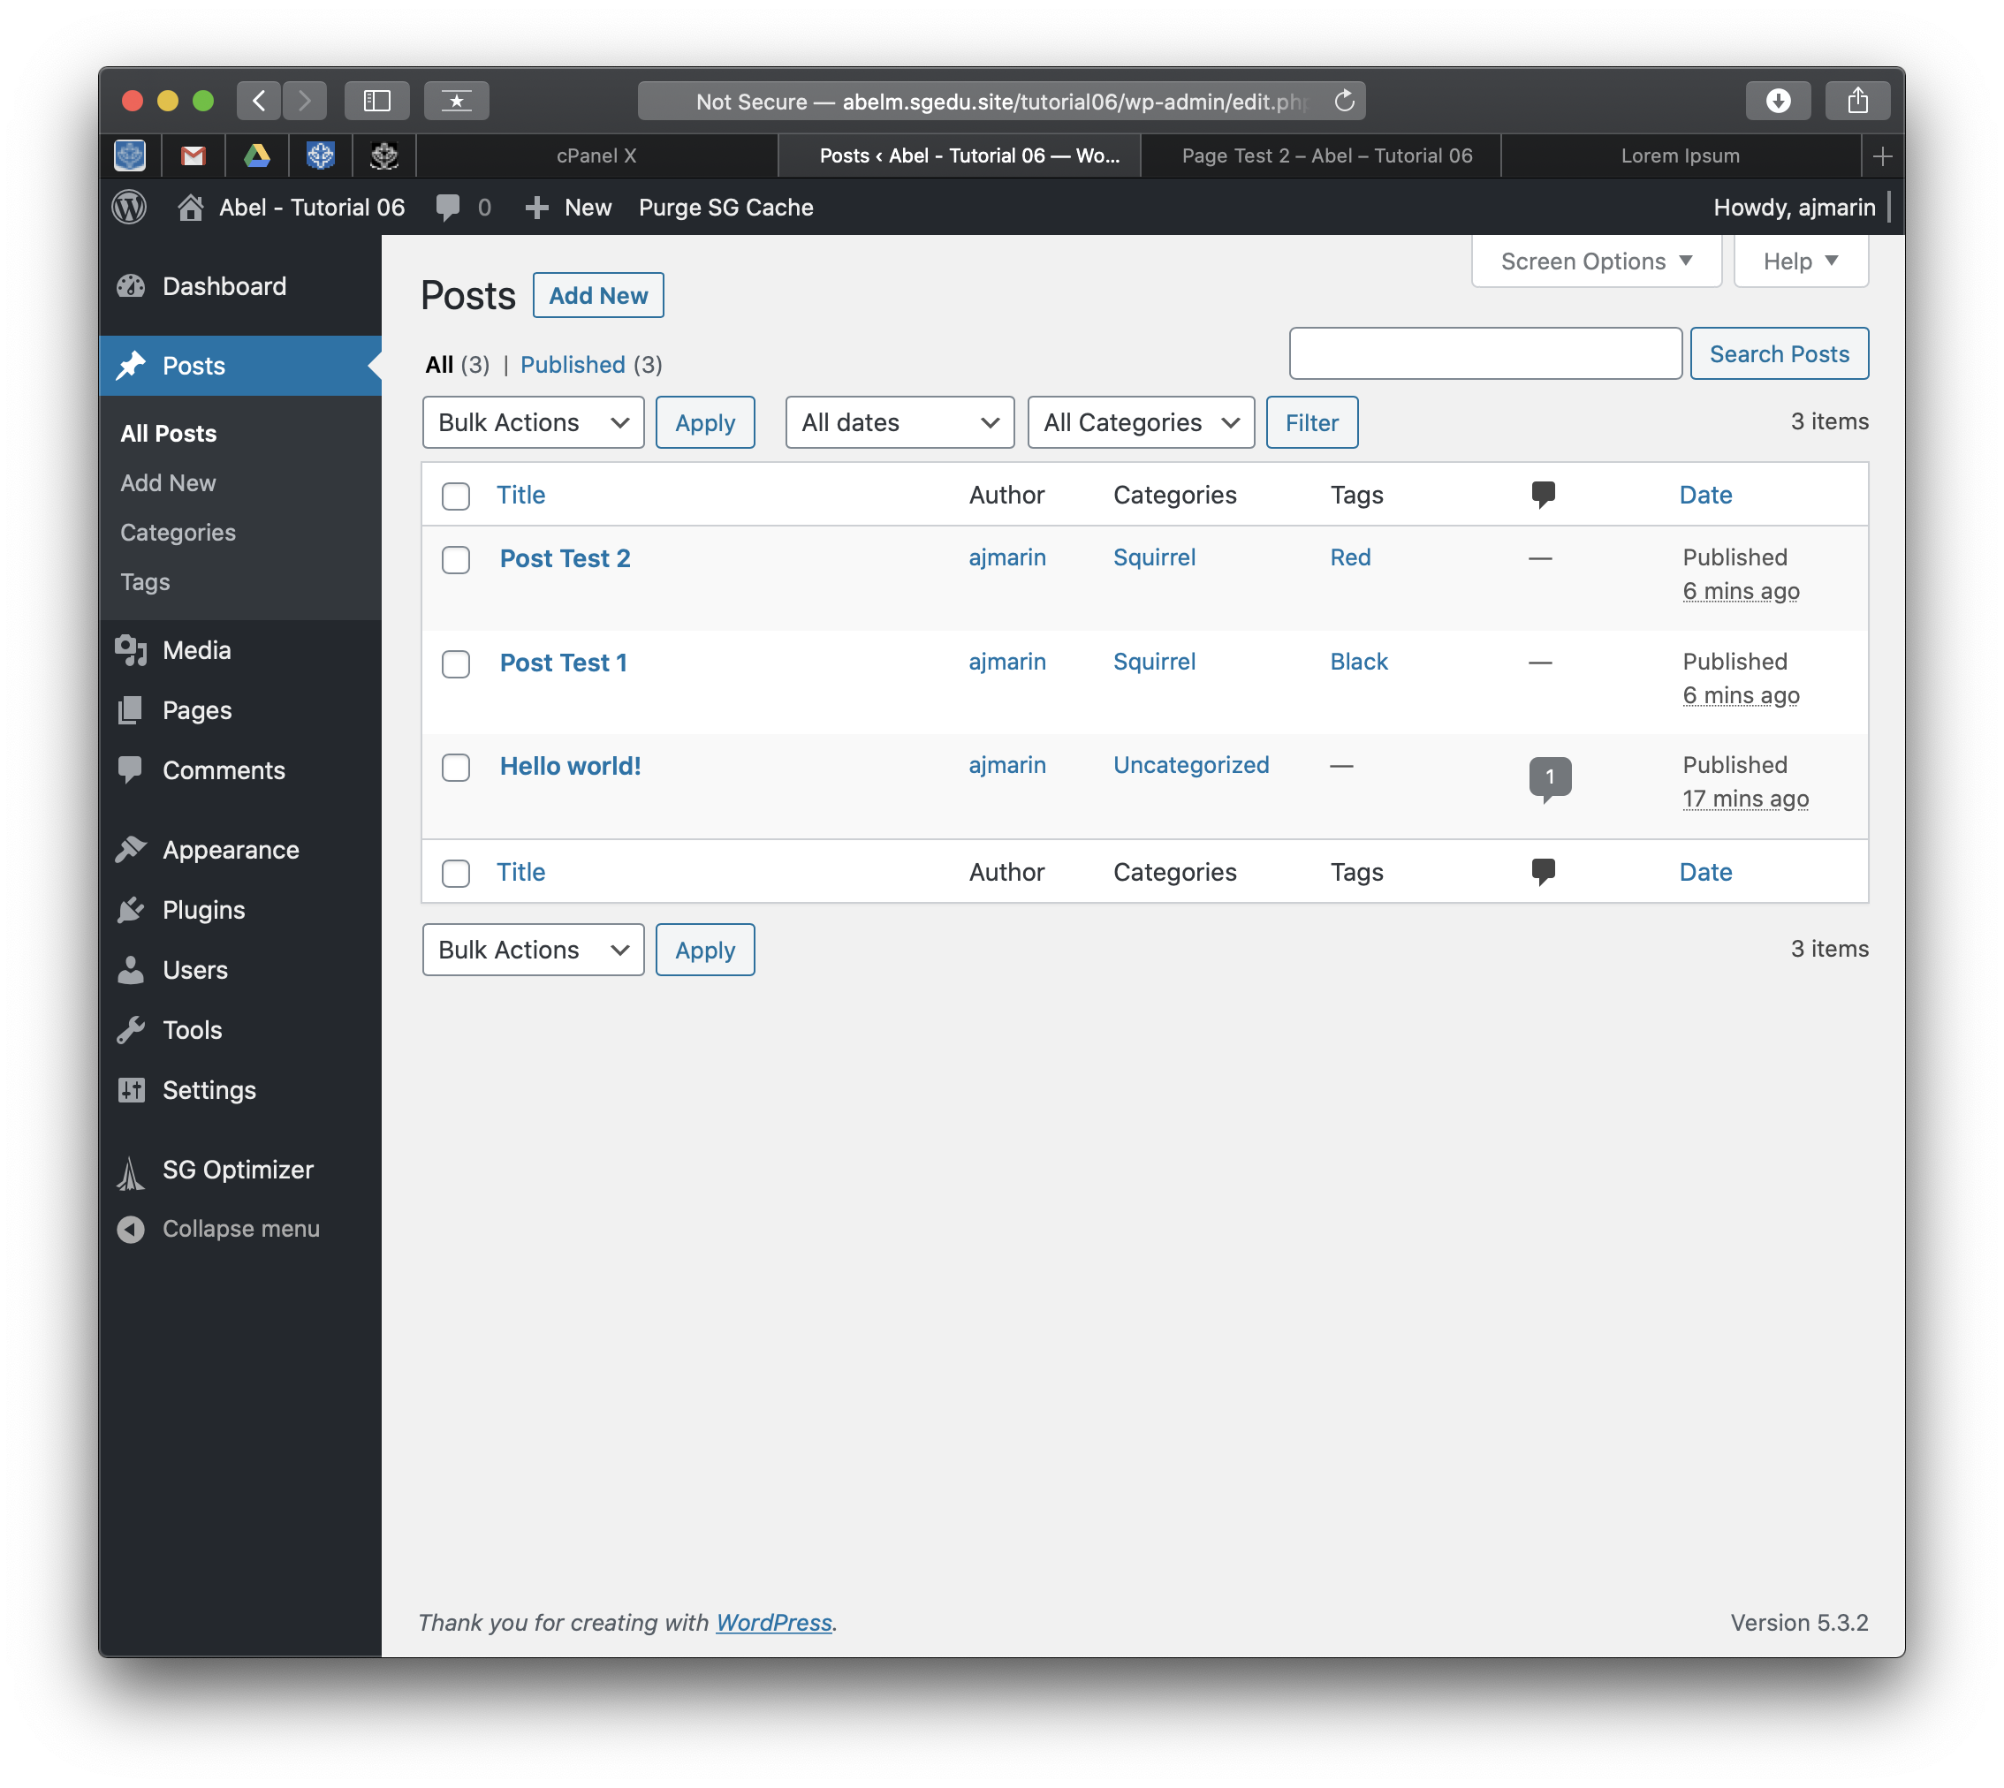]   
   Go back to the instructions and continue at Part D.**

**Part D – Role Based Security**

**Please make sure all Part D screen capture include the web browser address bar. [D]**

1. What are the six default WordPress roles? **[D.1]  
   [Administrators, Editors, Author, Contributor, Subscriber, Super Admin]**
2. Why are roles important in content management systems? **[D.2]**

**[ Roles are important because for most websites there will be a whole team working on and editing content on the website. Therefore it is important to make sure that people only have access to things that they need to use, for example a writer can create posts but they cannot add plugins since they should not have to worry about that. This helps with security, making sure that non admins do not break the site, and it helps to define a person’s role with the website i.e. authors write articles. ]**

**Go back to the instructions and continue at Part E.**

**Part E –** Review PHP Money Function

There are no template screen captures or template questions on Part E

**Go back to the instructions and continue at Part F.**

**Part F –** Review PHP Date & String To Lower (strtolower) Function

There are no template screen captures or template questions on Part F

**Go back to the instructions and continue at Part G.**

**Part G – Import the Adapter Plug Table**

**Please make sure all Part G screen capture include the web browser address bar. [G]**

1. WordPress Database name: **[ wp829 ] [G.1]**
2. WordPress Database Prefix: **[** wpcu_ **] [G.2]**
3. phpMyAdmin screen capture with the database selected and the Adapter Plug table with correct DB table prefix listed on the left **[G.3]  
   [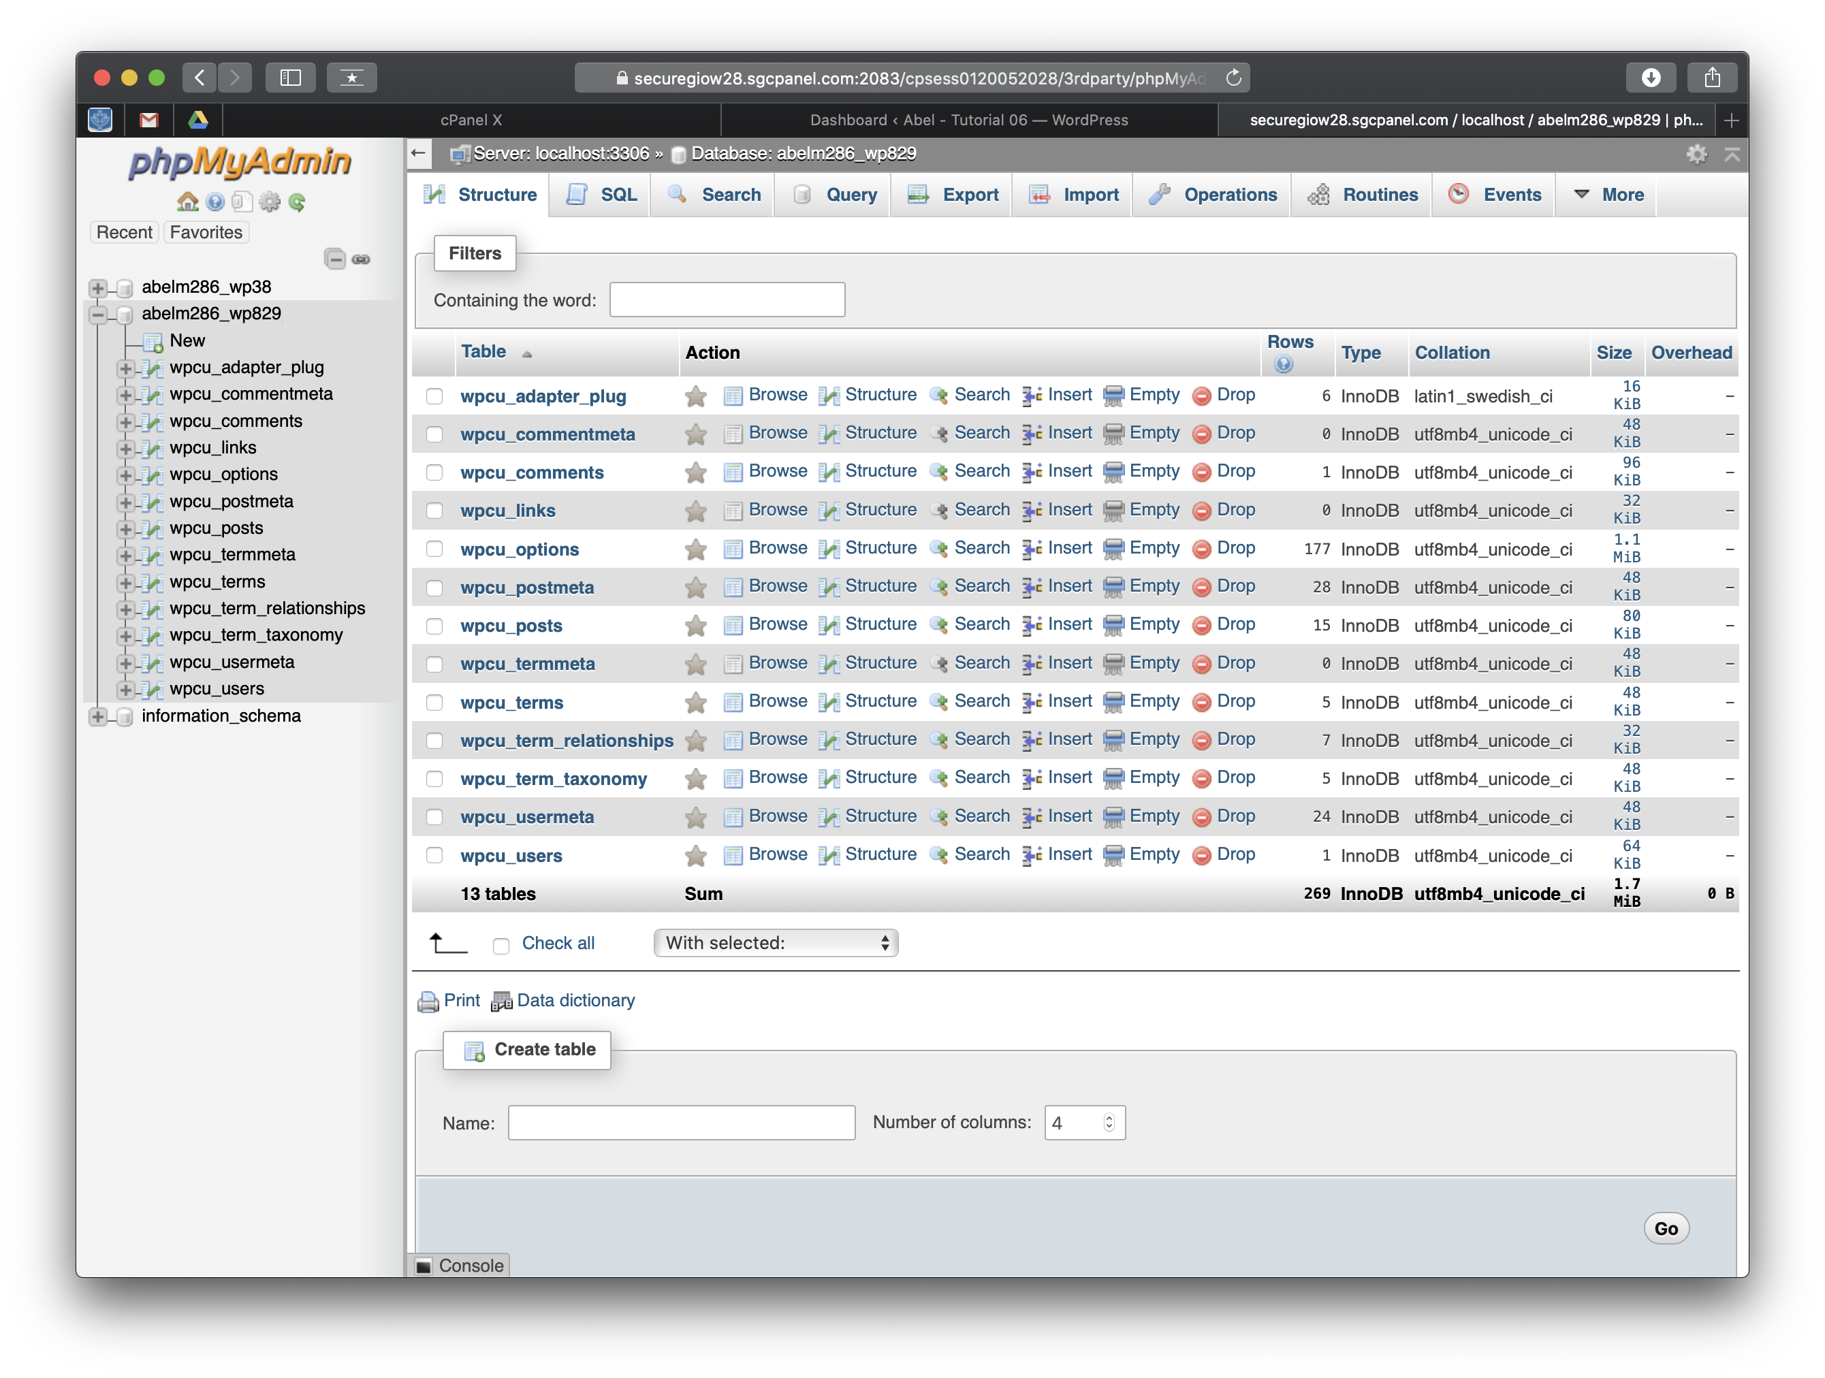]**
4. phpMyAdmin – select the adapter table and take a screen capture of its structure **[G.4]  
   [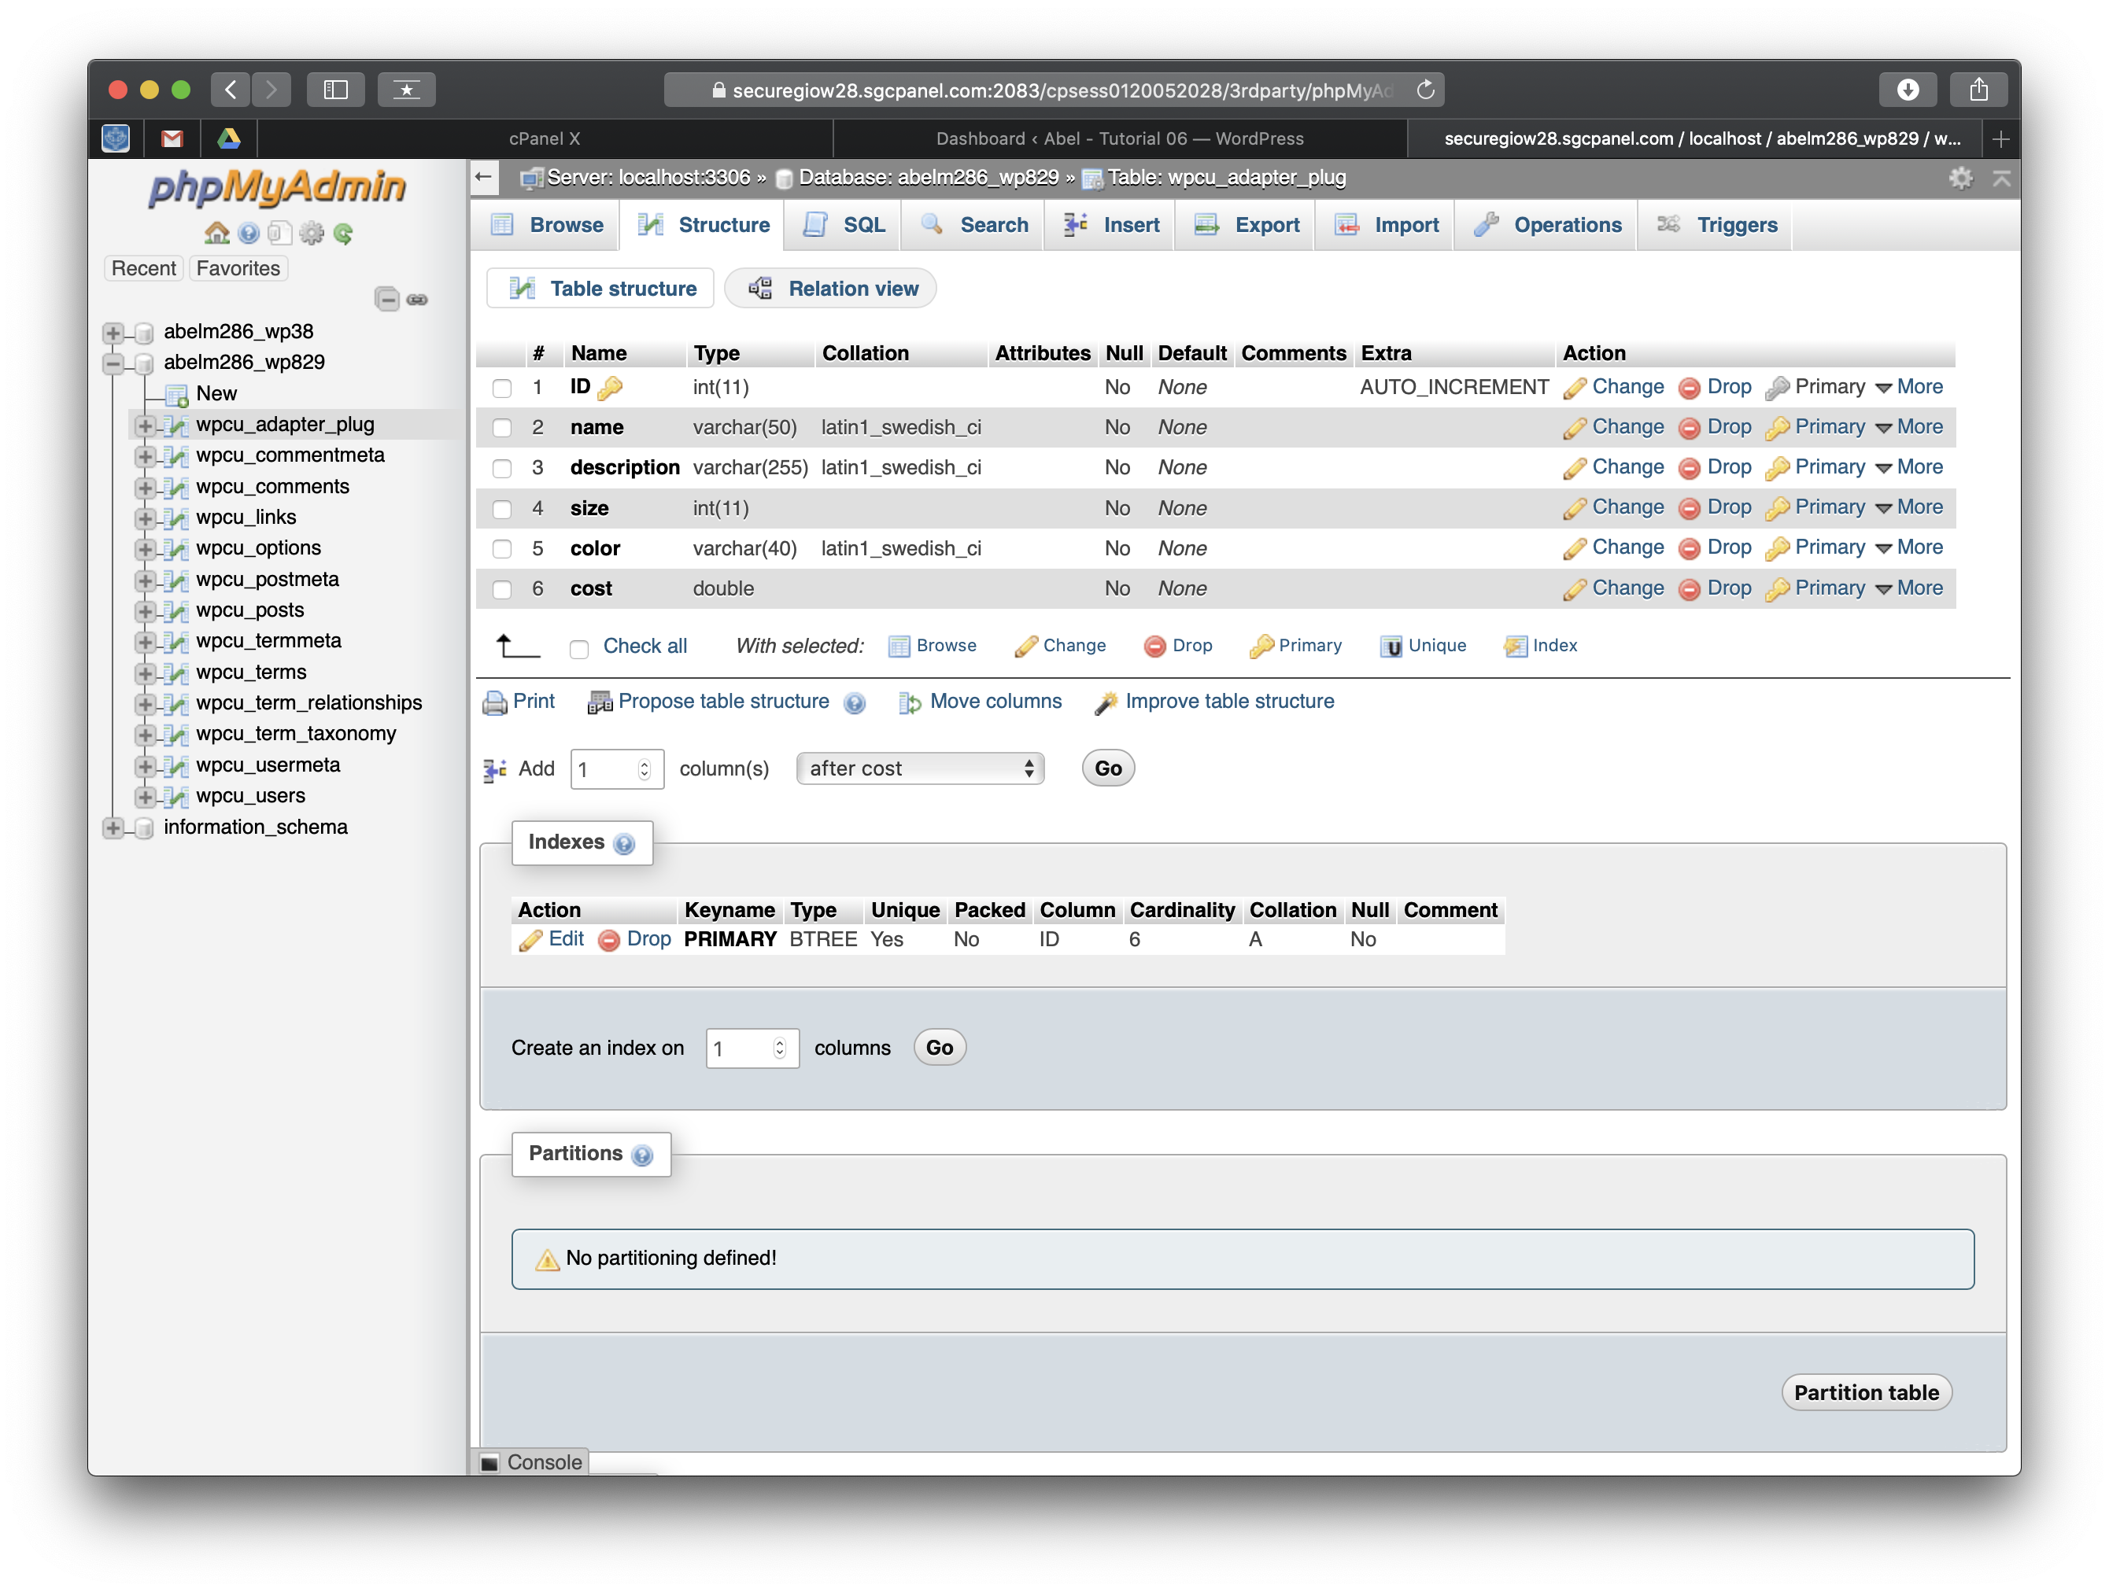]**
5. phpMyAdmin – select the adapter table and take a screen capture of its contents (Browse) **[G.5]  
   [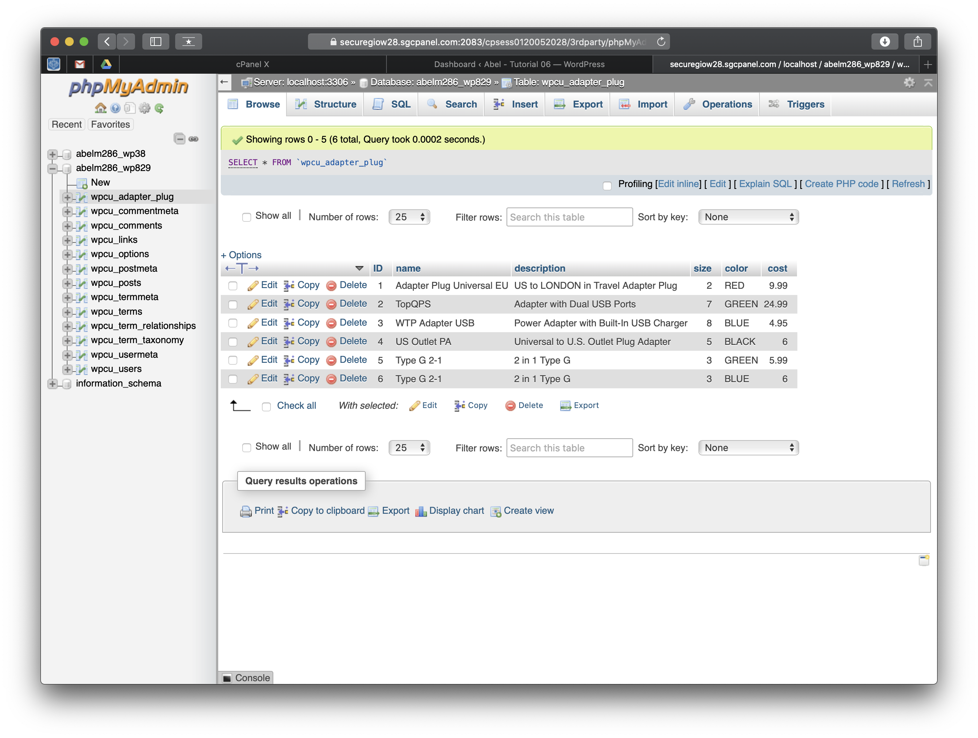]**

**Go back to the instructions and continue at Part H.**

**Part H –** Create an Advanced Custom PluginExtend WordPress with Adapter Plug Custom Plugin

**Please make sure all Part H screen capture include the web browser address bar. [H]**

1. Take a screen captures of the backend Plugins page with the Adapter Plugin activated **[H.1]  
   [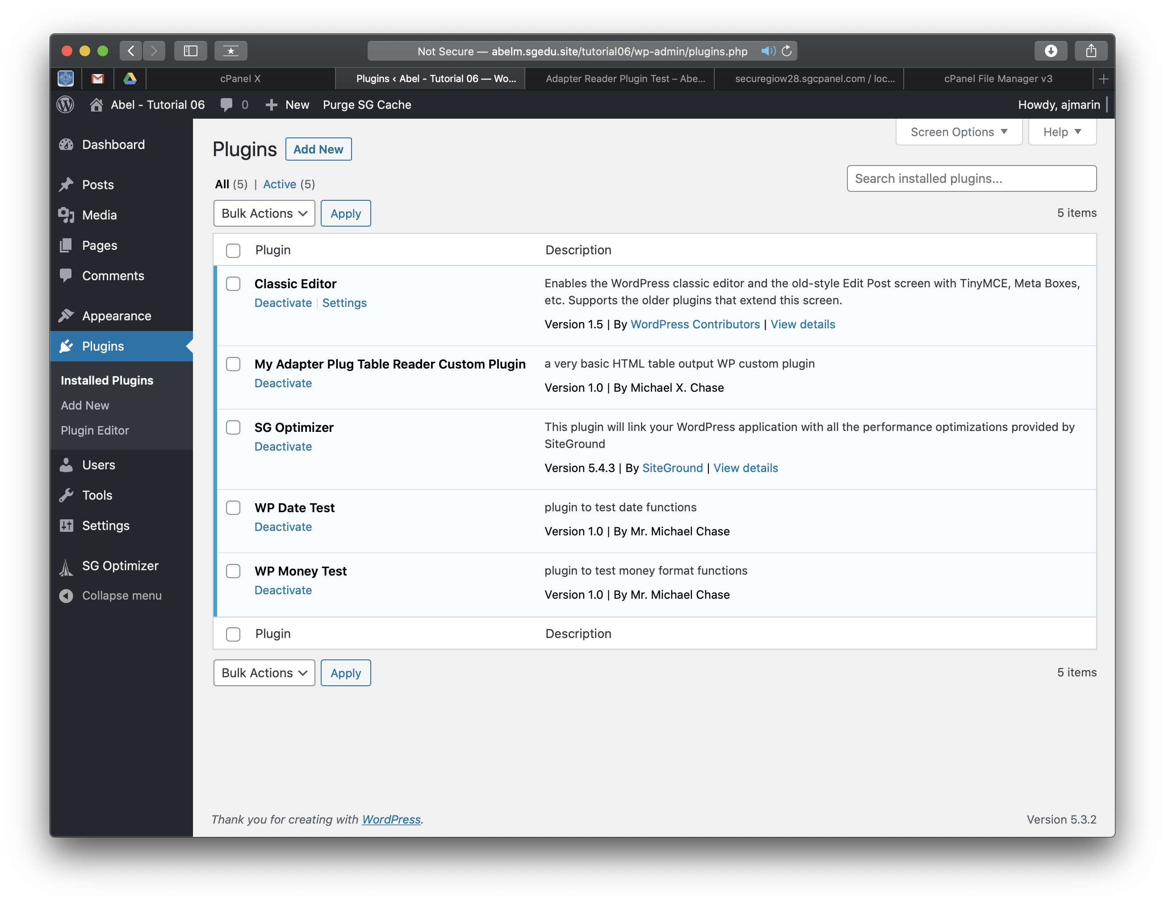]**
2. Front-end website screen capture of the adapter plugin test page that displays the Adapter table data in an HTML table per requirement specifications. **[H.2]  
   [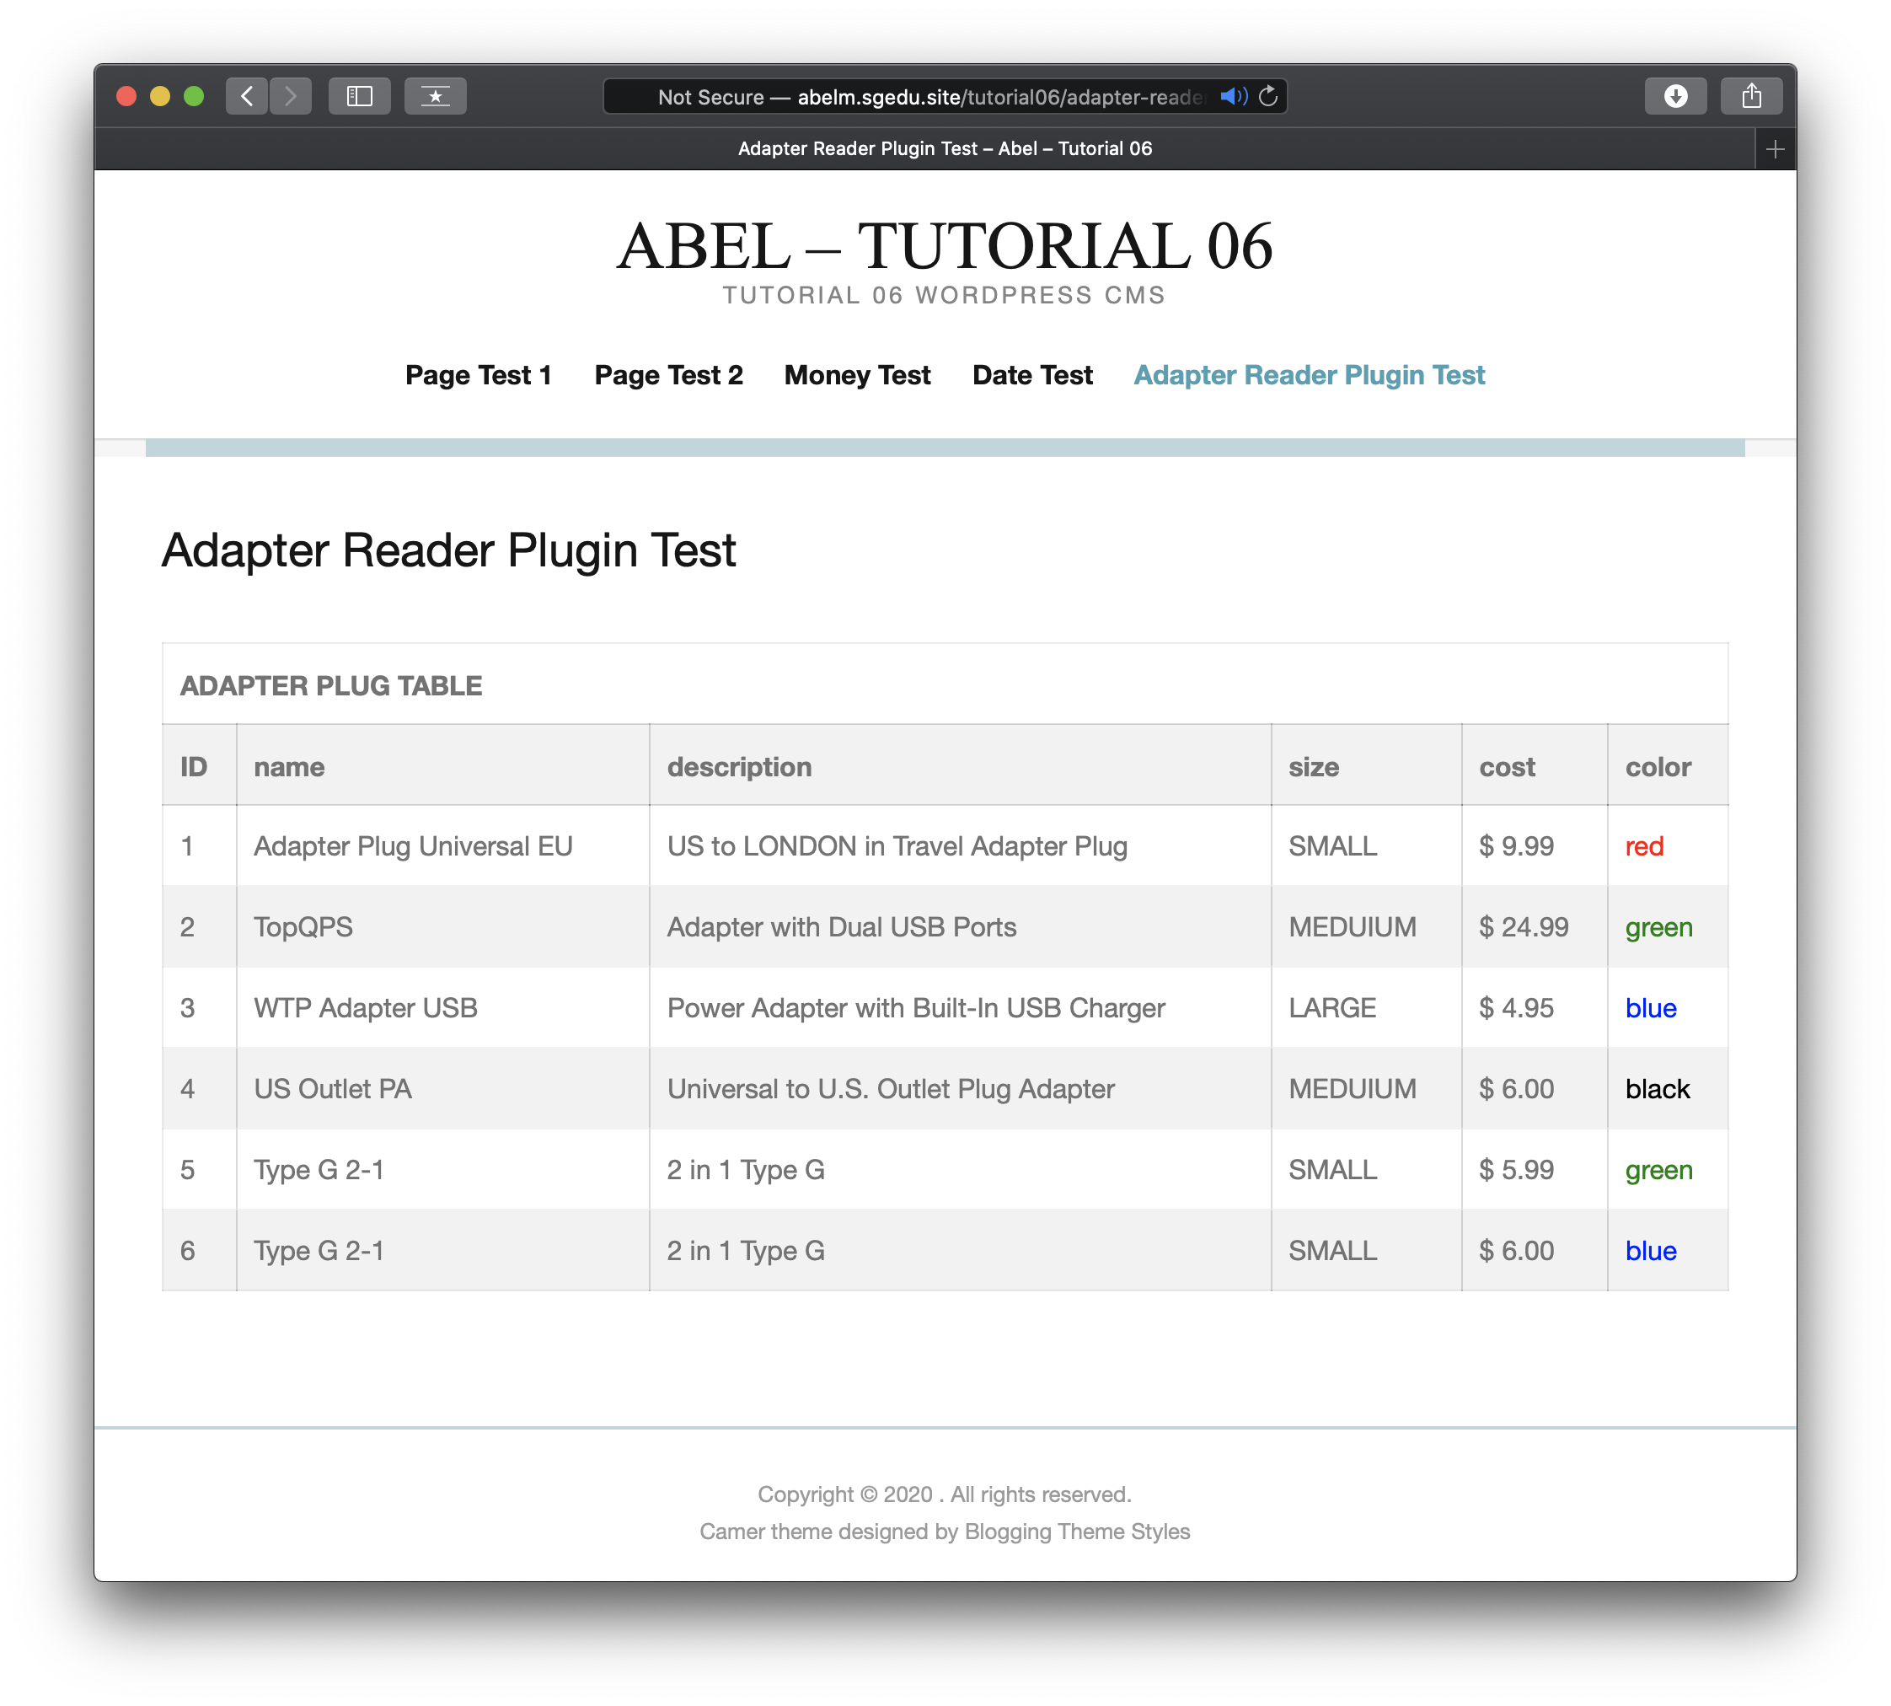]**

**Go back to the instructions and continue at Part I.**

**Part I – Create a WordPress site on Codeanywhere from a Git URL[I]**

1. Enter the following shared web host WordPress site information **[I.1]**
   1. Codeanywhere account username(email): [ marinabe1416@gmail.com ]
   2. Codeanywhere account password): [ Dbeu!315 ]
   3. Tutorial WP Site URL: [ <https://ajmtutorial6ca-marinabe1416545968.codeanyapp.com/> ]
   4. WordPress site Admin Username: [ student ]
   5. WordPress site Admin Password: [ xxx123!!! ]

Please make sure all Part I.2-10 screen captures include the web browser address bar.

1. Git Clone URL used for Part I: **[I.2]**  
   **[** [**https://github.com/mikehchase/it320tutorial05.git**](https://github.com/mikehchase/it320tutorial05.git) **]**
2. Take screen captures of the phpMyAdmin with the wordpress database selected – showing all existing tables on the right side and middle of the web page. **[I.3]  
   [ 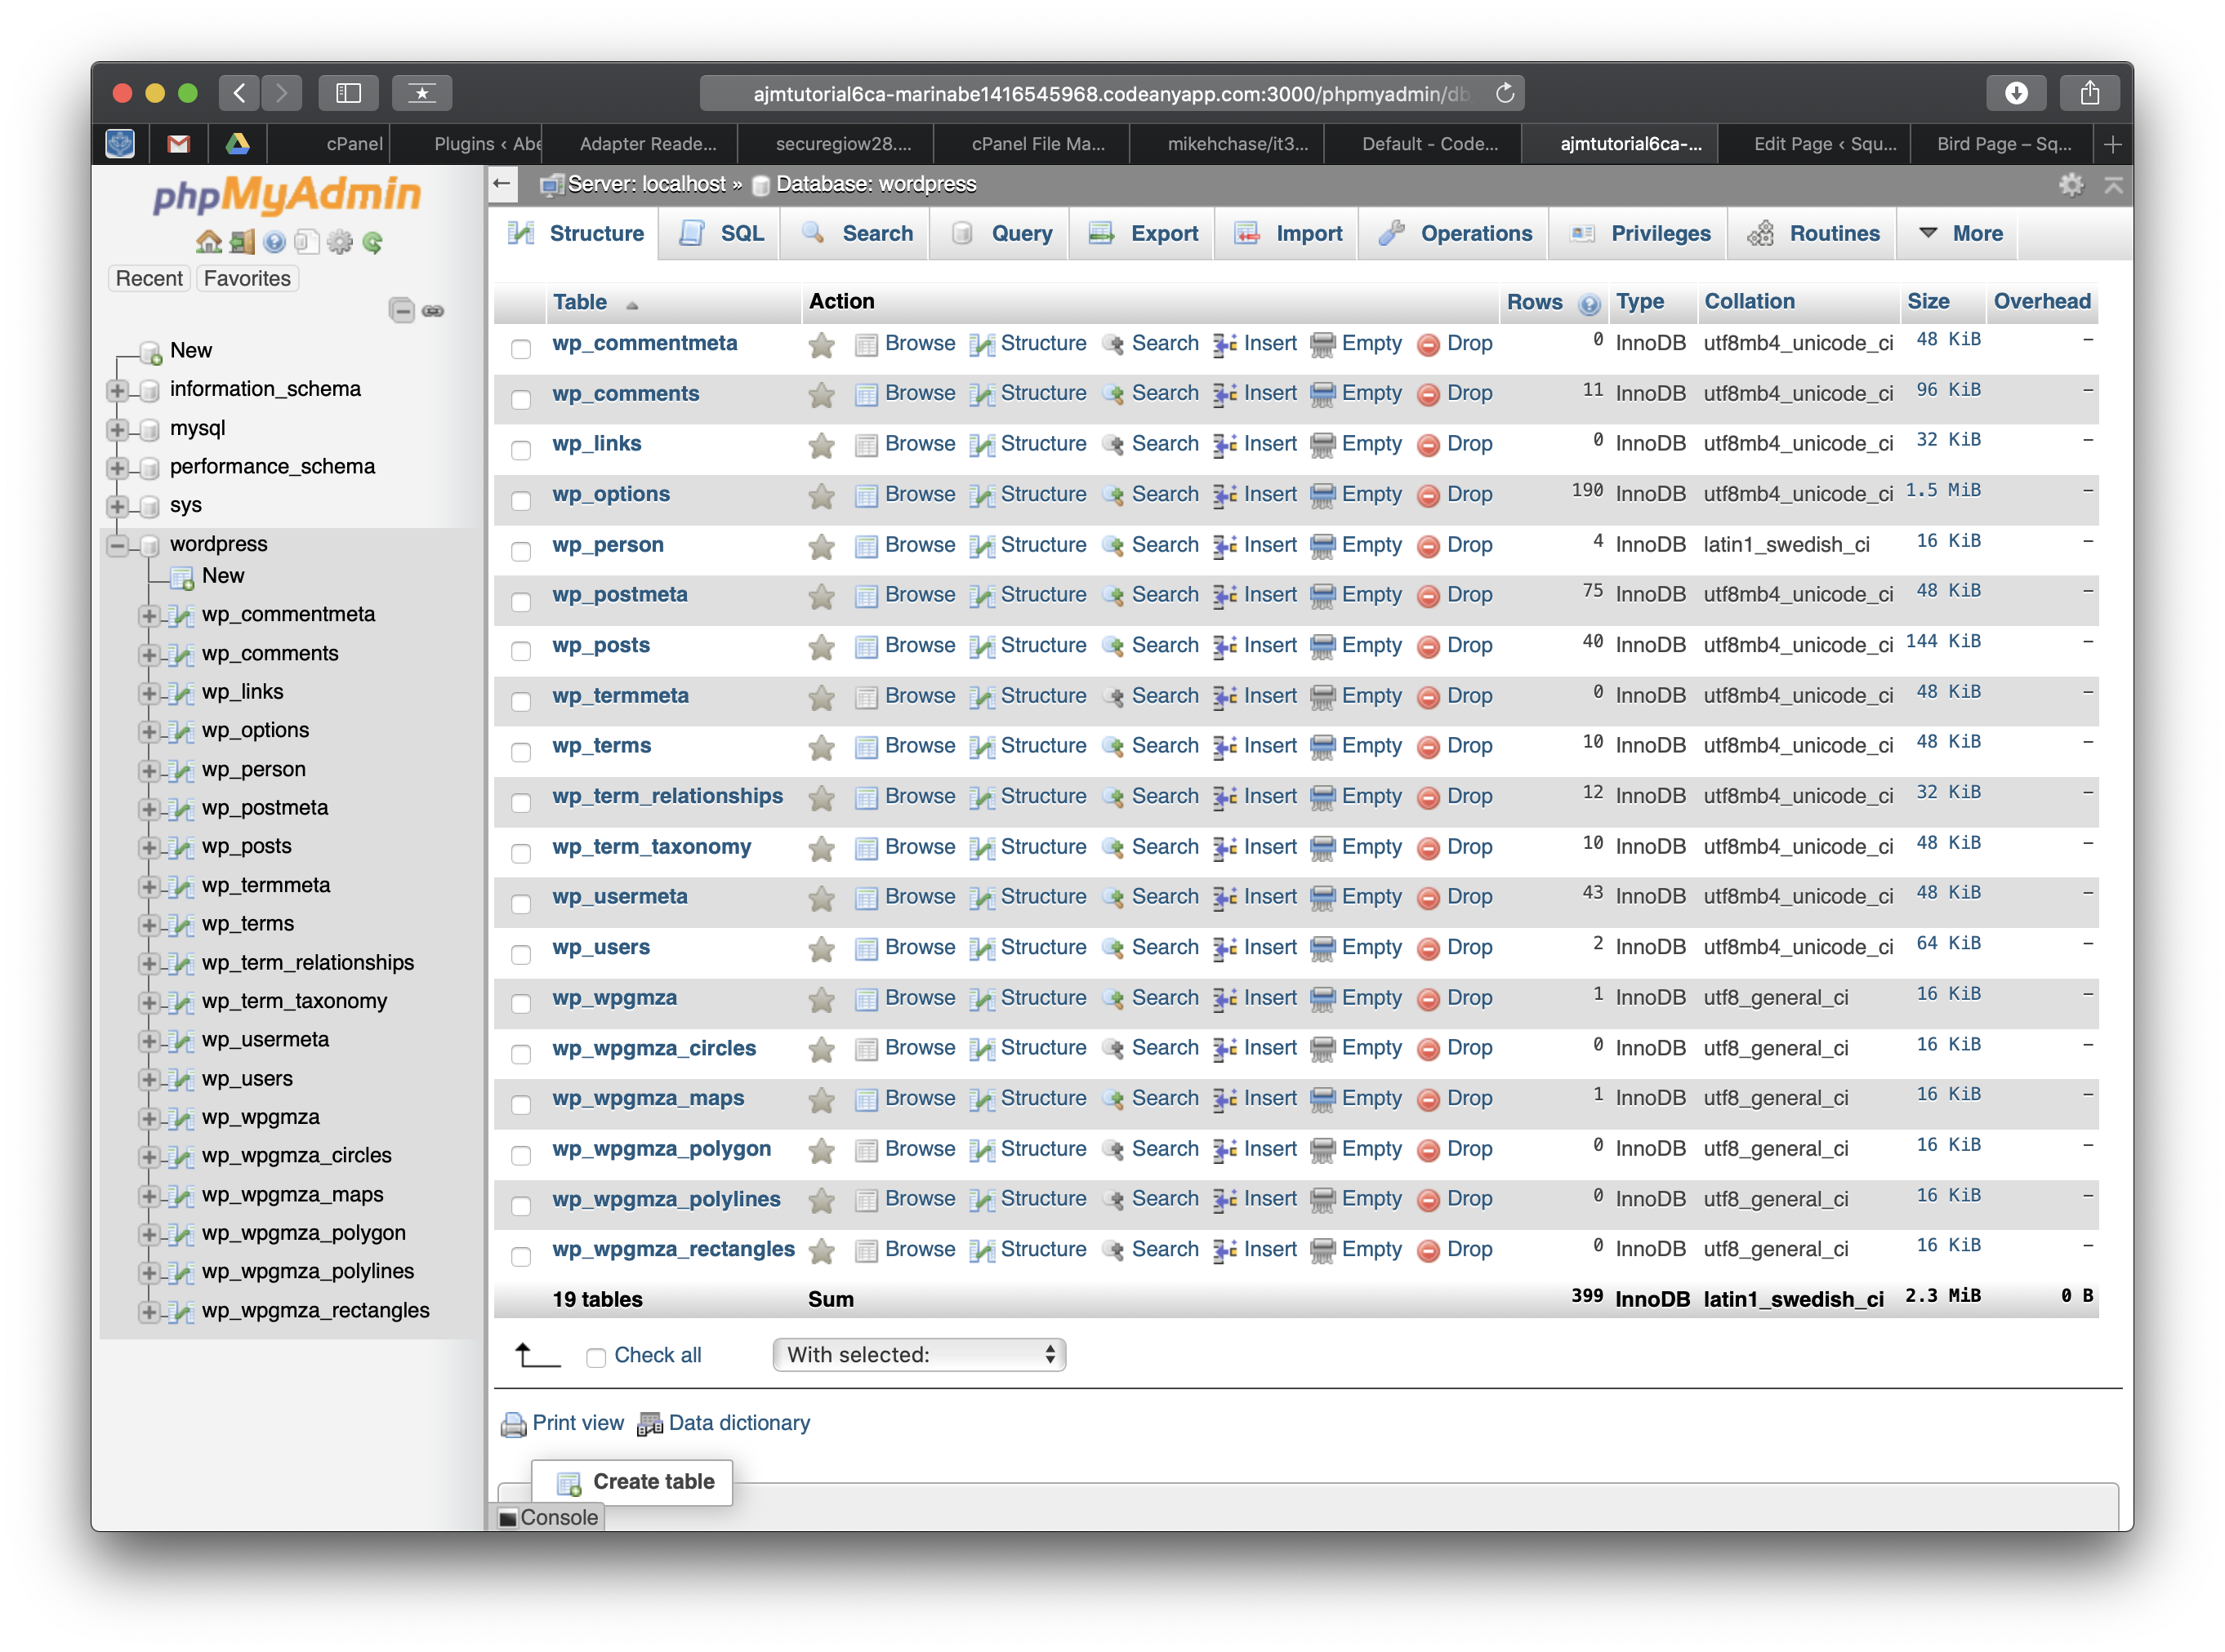]**
3. Take screen captures of the Codeanywhere user interface with the File Explorer fully root container/connection expanded and the web browser address bar visible **[I.4]  
   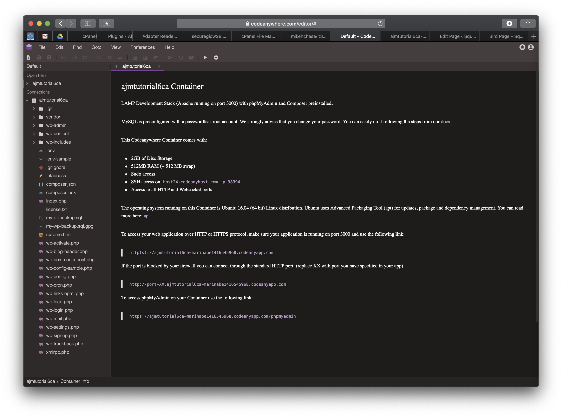[]**
4. Take screen captures of the Codeanywhere .env file contents and the web browser address bar visible **[I.5]  
   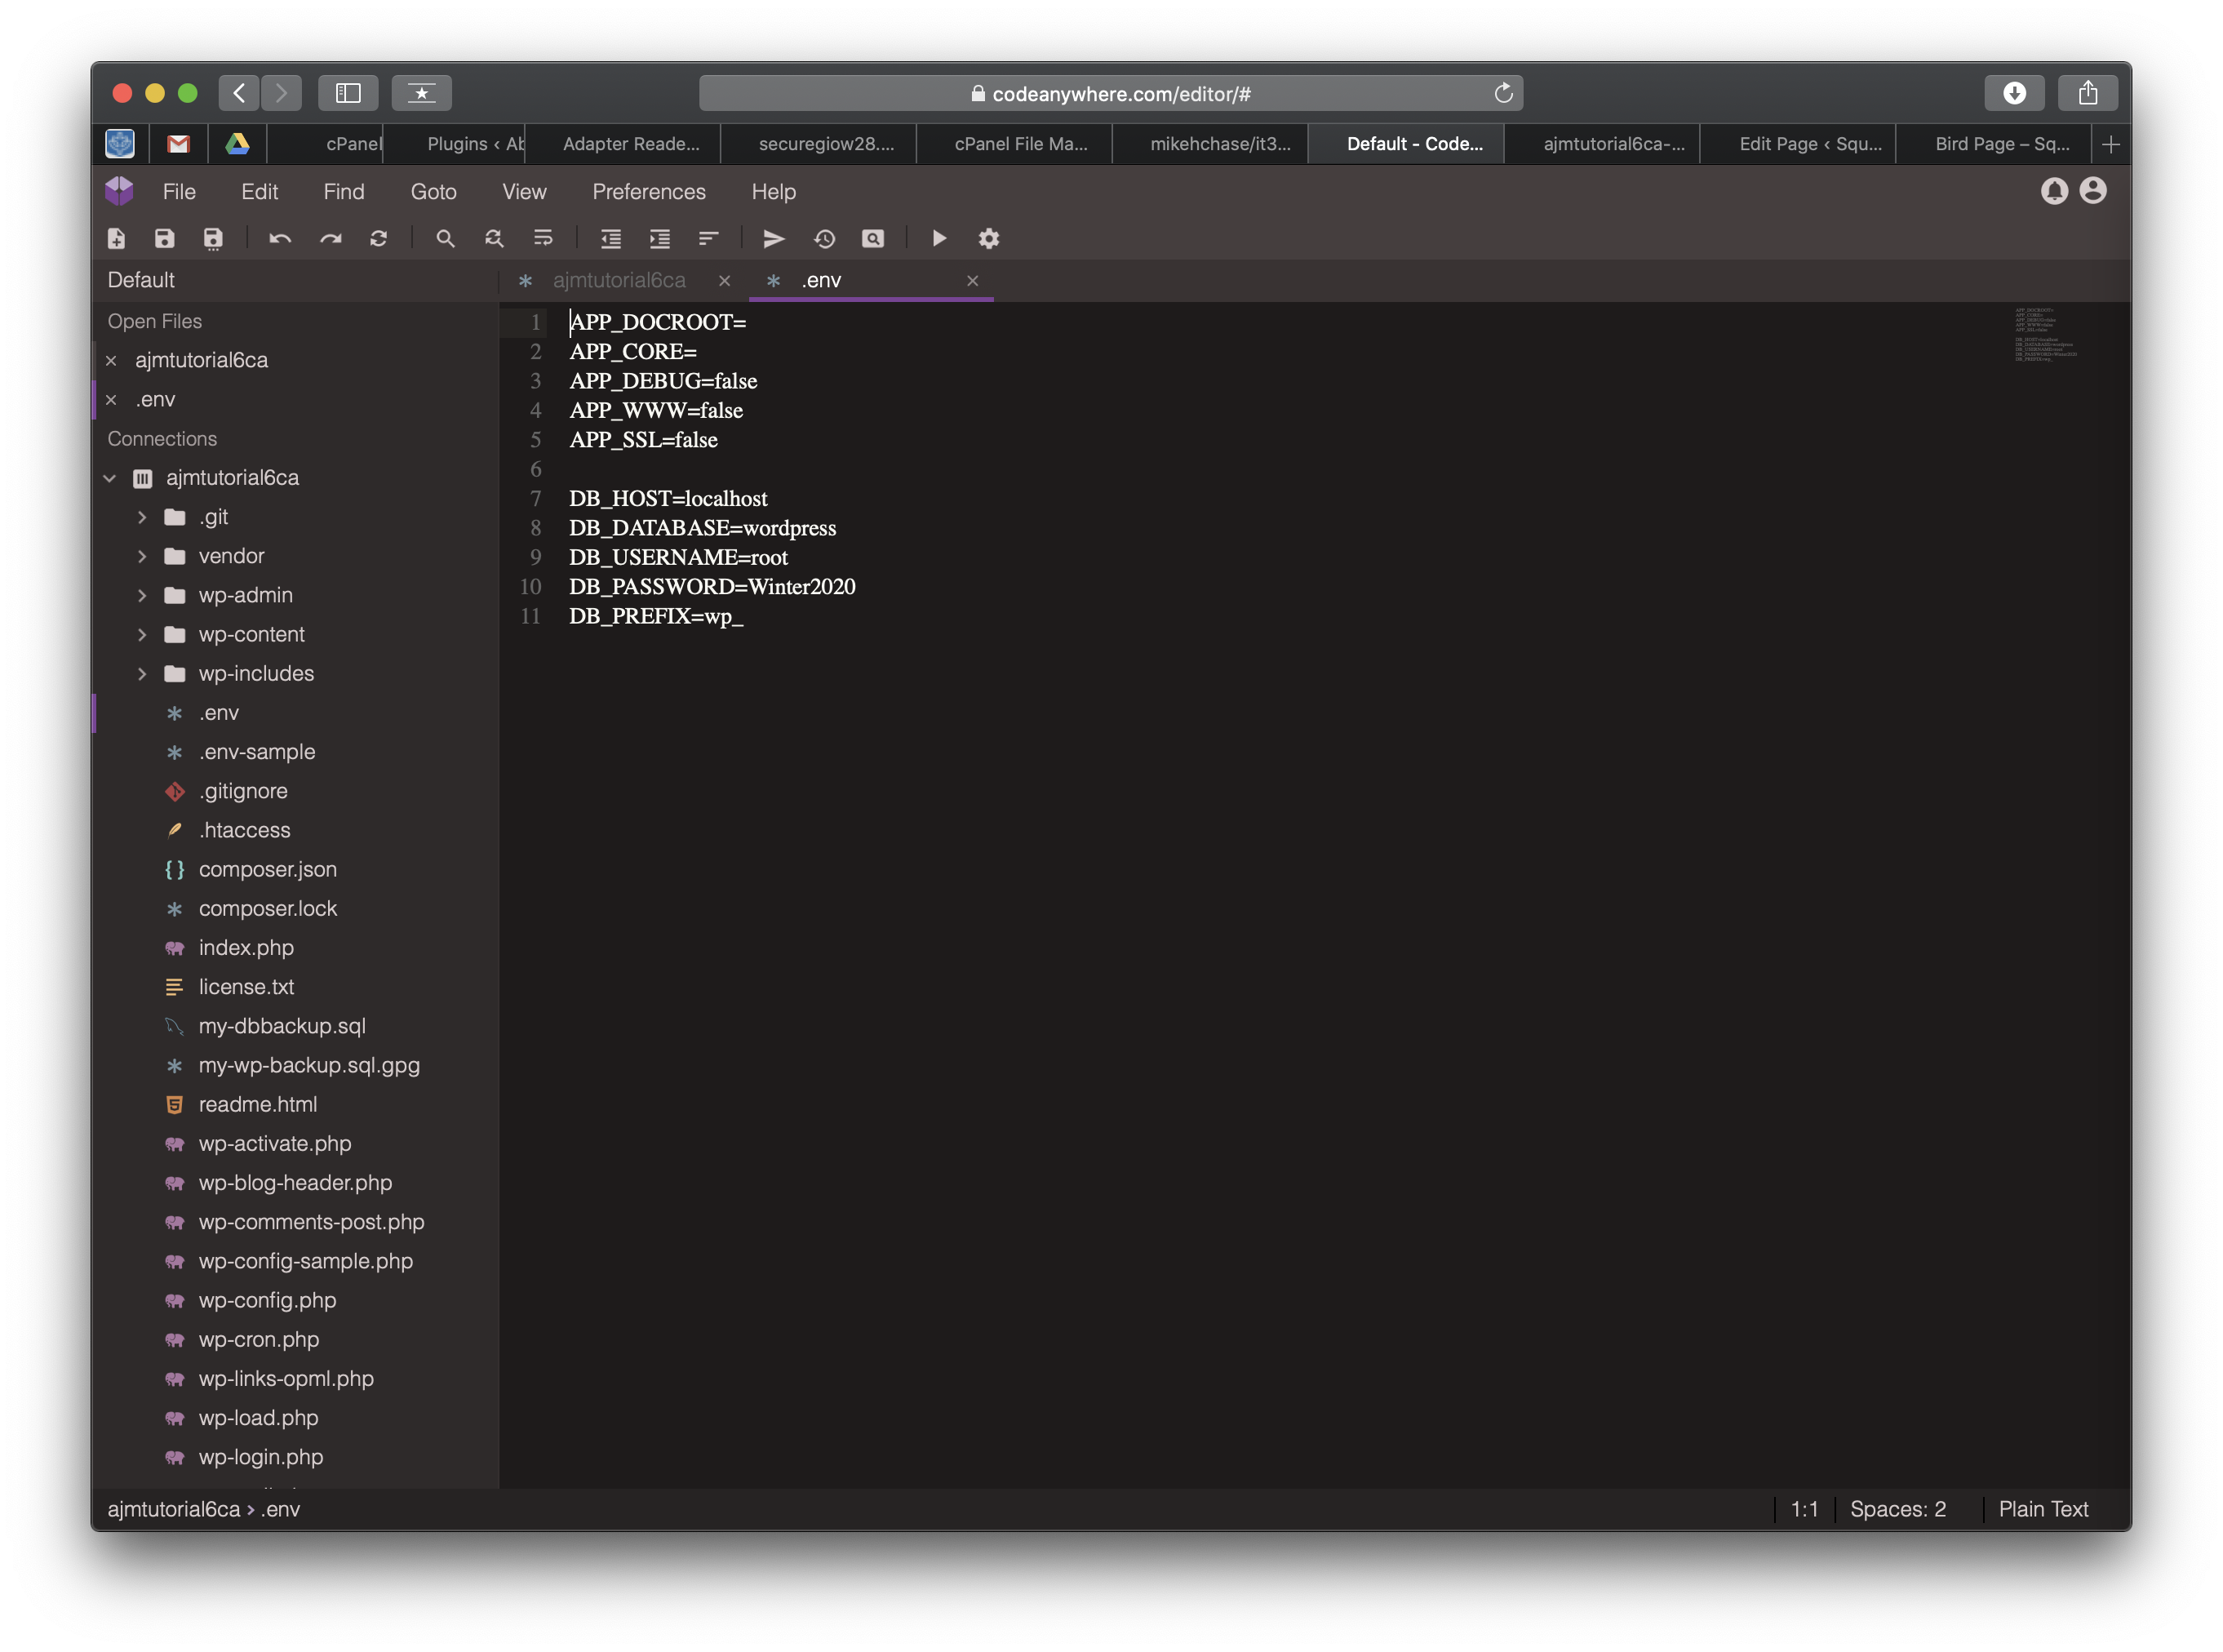[]**
5. Take screen captures of the backend administrative WordPress Dashboard > home **[I.6]  
   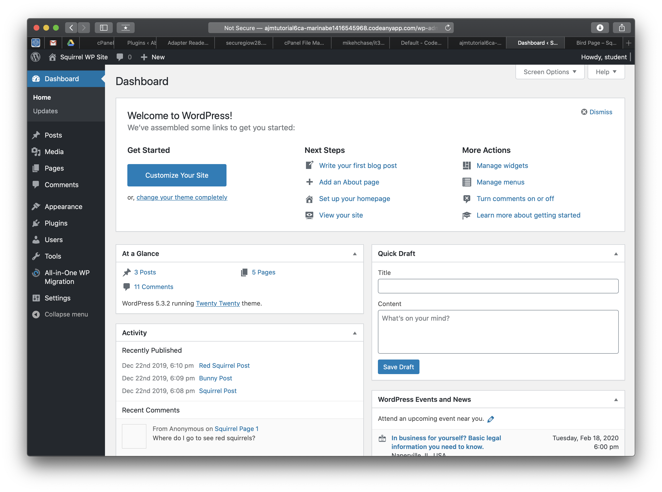[]**
6. Take screen captures of the backend administrative WordPress Dashboard > Posts **[I.7]  
    [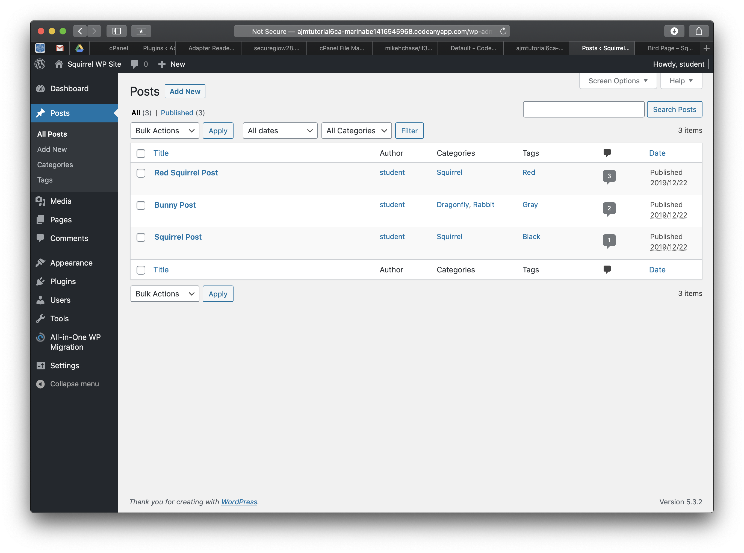]**
7. Take screen captures of the backend administrative WordPress Dashboard > Pages **[I.8]  
   [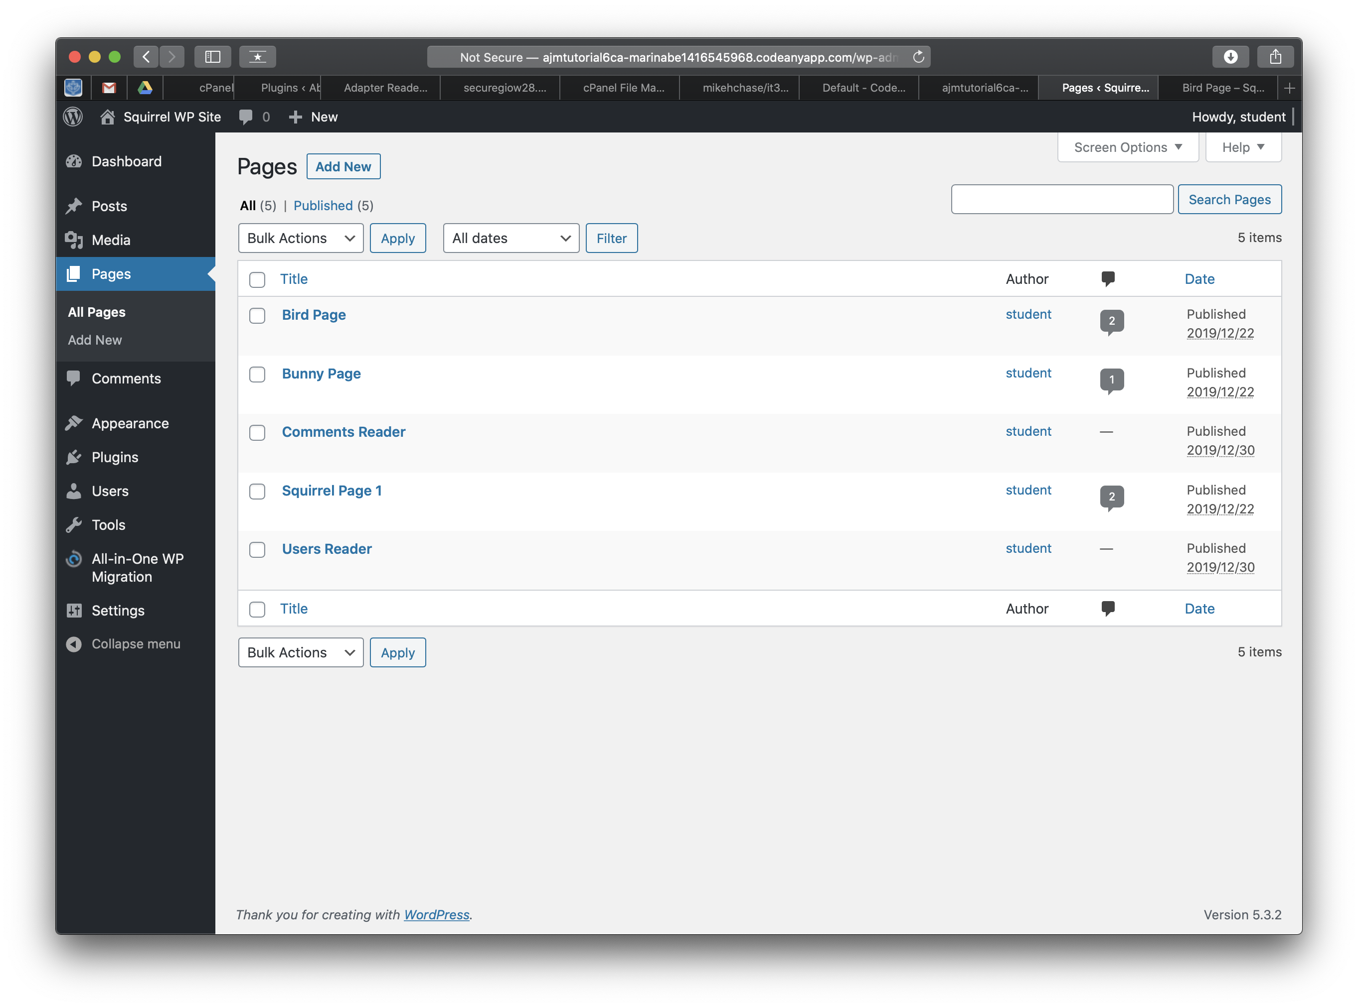]**
8. Take screen captures of the WordPress Frontend home page showing a Post **[I.9]  
   [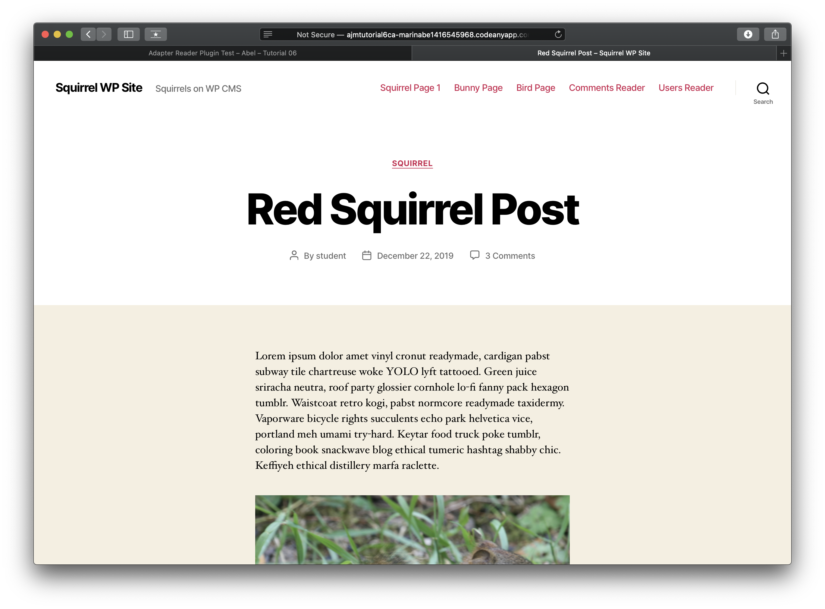]**
9. Take screen captures of the WordPress Frontend showing a selected Page **[I.10]  
   [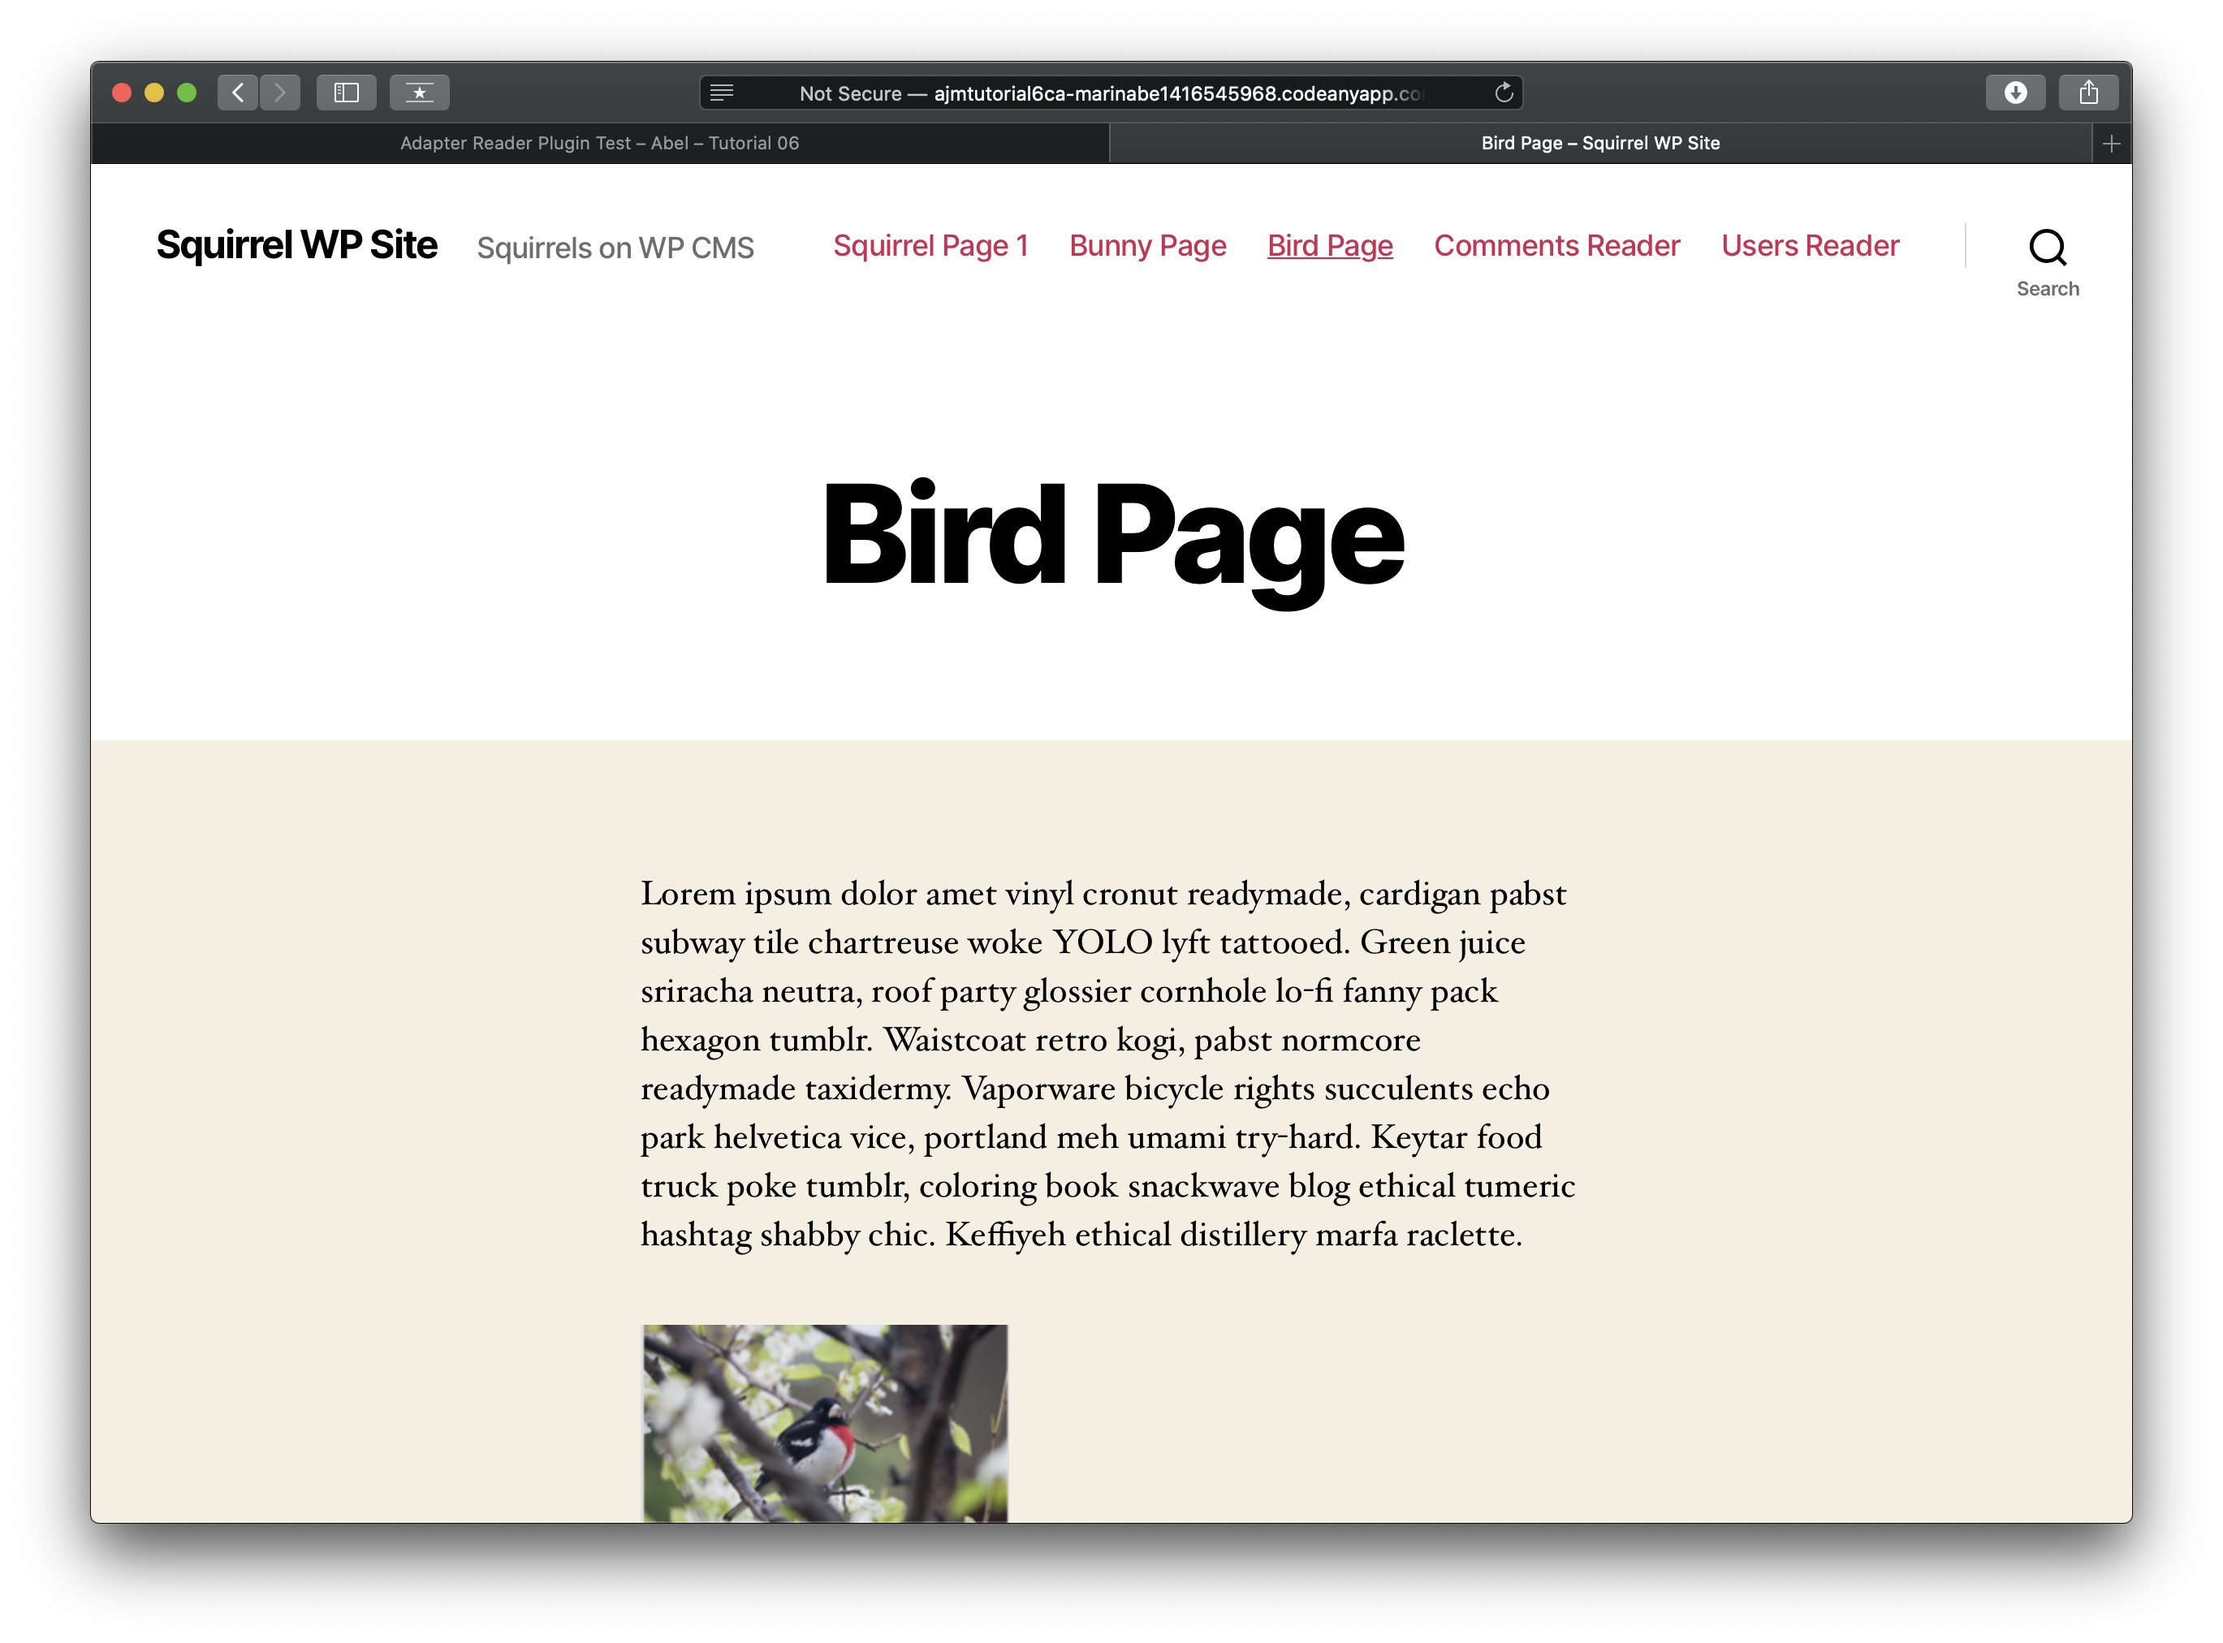]**

**Go back to the instructions and continue at Part J.**